Mayas, Aztecs, and Incas: Processing Activity
You will be designing a mosaic tile about these societies to hang in a museum (our classroom). This assignment will only be graded if it is turned in as a mosaic piece of art.
Step 1- decide the design of your mosaic. Will it be just a pattern or will it create a picture with the “tiles”?
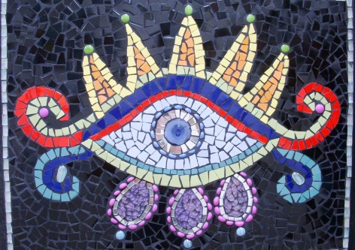
Step 2- Draw the pattern or picture so you know the shape of your “tiles”. Be sure that your pattern or picture can be divided into at least 9 tiles (separate shapes). Mosaic tiles are usually different shapes and sizes- they are not usually uniform.
Step 3- determine the 3 most important achievements for each society (Maya, Inca, Aztec)- 9 total.
Step 4- the achievements from step 3 will become “tiles” in your mosaic piece of art.
- If your mosaic is divided into 9 shapes, then each shape becomes an achievement tile.
- If your mosaic is divided into more than 9 tiles, the extra tiles that are not achievement “tiles” can be colored in- they should not have drawings on them.
Step 5- each “tile” needs to be a creative and colorful visual symbol of the achievement you chose. Make this happen.
Step 6 – On the back, write a one sentence summary of each image, so that you are prepared to present to the class.
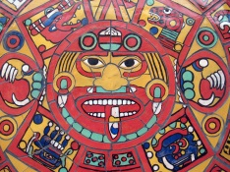 /25 pts

