Ancient China Placards
Placard A: The geography of China has led to periods of _______________________.
Isolation to me means…

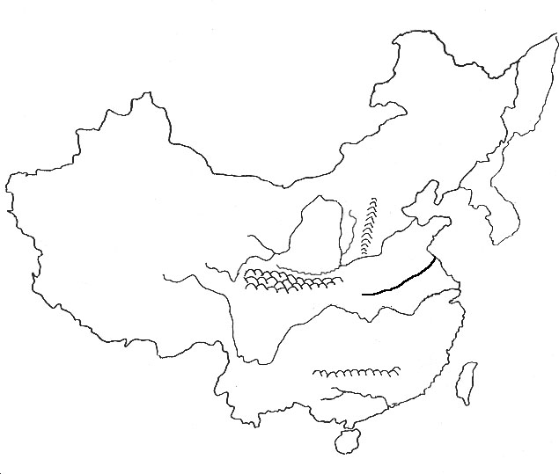
Label the Rivers, seas, and mountains that cut China off from other lands.
Explain three ways that China’s geography cut them off from other countries.

Placard B: What was the Mandate of Heaven? What control did the Emperor have?

What was the social class structure in China like? Draw a graphic to help you remember. It must be diffferent from mine.

Placard C: Why have different religions and philosopies developed in China? What the the main ideas of:
Confucious:

Taoism (Daoism):

Buddhism:
Placard D: What is Confucianism?

What is the key belief of Confucianism?

Placard E: What is a Dynasty? How long did this system of government last in China?

Placard F: How was the Xia Dynasty different from later dynasties?

What is the major contribution of the Shang Dynasty?

Under what Dynasty did the Mandate of Heaven develop?

Placard G: Describe the impact of Mongol rule in China. How did they gain power and how did they lose it?

Placard H: What were the contributions of the Ming Dynasty?

What changed during Ming Rule?

Placard I: Summarize what happened under the Quin Dynasty?

Placard L: What was the purpose of the Great Wall of China?

What is the significance of the Great Wall of China?

Placard M: Explain three details about the Terracotta Army.

Placard N: What impact did the Grand Canal have in China?

Placard O: Describe the Forbidden City.

Placards J and K: Use the rest of this sheet of paper to create a graphic organizer/drawing explaining and labeling the Chinese contributions of paper, gun powder, magnetic compass, wood block printing, porcelain, paper money, canals, and moveable type.

From your memory: Be detailed and use facts. What are three other things that you learned from this activity that I did not ask you about?

