Armenian Genocide, WWI and the Russian Revolution Study Guide – 25 pts due the day of the test
Country Name | Correct letter/s
 | A
 | B
 | D
 | F
 | G
 | R
 | DD
 | I
 | BB
 | CC
 | P
 | Q
 | O
 | K
N
M
 | S
 | C
 | E
H

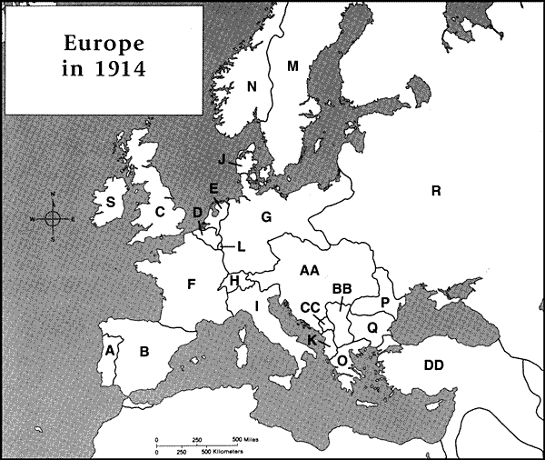
Central Powers Allied Powers
Color the map to identify sides of the war.

J
AA
L

Give an example for each level of the pyramid of hate from the Armenian Genocide or WWI
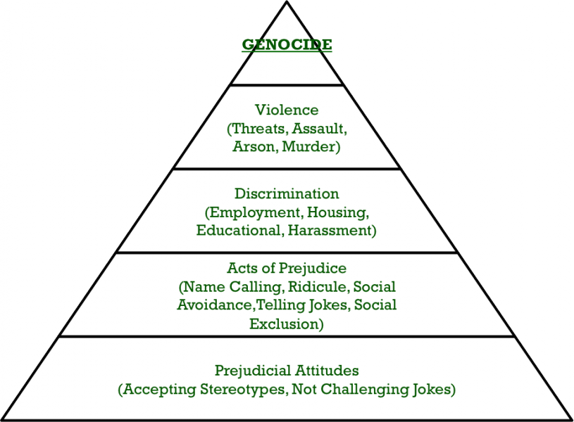

What was the Armenian Genocide (who, what when, where, how, why)?
T F The spread of Nationalism throughout the Ottoman Empire caused the Ottoman empire to break apart.
T F Isolated Armenians were the only major Christian minority.
T F Armenians began to call for independence and better treatment from the Ottoman Empire.
T F The Armenian Genocide was carried out during World War One between the years 1925 and 1930.
T F The Turkish government continues to deny the genocide of the Armenian today.
Define:
Genocide

Propaganda:

Cavalry:

What are the four MAIN causes of WWI?

What region is nicknamed “the powder keg of Europe”? Why?

Explain in sequential order the “spark” of World War One

How does Belgium’s neutrality “contribute” to the war?

Which countries make up “The Allies? In 1914

Which countries make up “The Central Powers” in 1914?

What new technology was used during WWI? What does this lead to? Why?

Explain what trench warfare was like during WWI?

What is no man’s land?

What is a stalemate and how does it relate to WWI ?

What is total war? Provide two examples.

How did women contribute to the war effort? What might this lead to in regards to women’s rights?

Define propaganda and explain how it was used during WWI?

Explain the morale of troops and civilians prior to United States entry into the war.

What are the 2 significant events from 1917?
1.

2.

Explain why the United States enters WWI.

What claims does Wilson make about WWI as he enters the war?

Define Armistice and briefly explain the end of WWI

Explain the consequences Germany faced following the Treaty of Versailles

Be able to explain which country lost the most land after the settlements of WWI .

What new countries were created after WWI (name 4-5)
1.
2.
3.
4.
5.
How did WWI affect European control in parts of the Middle East?

True or False
T F Prior to WWI, Europeans glorified war.
T F Germany was blamed as being solely responsible for WWI at the Paris Peace conference (Treaty of Versailles)
T F A Stalemate is a situation in which Germany gained a clear advantage in the war
T F The Archduke of Austria Hungary was assassinated by a Serbian man and this event sparked WWI
T F The British fought on the side of the Central Powers

Russian Revolution
Define and explain how the following relate to the Russian Revolution:
Collective

Command economy

socialist realism

soviets

totalitarian state

Five-Year plans

Great Purge

What was Lenin’s New Economic Policy?

How did Stalin rise to power?

Explain life under Stalin’s rule in the USSR.

Why did the monarchy collapse in March of 1917?

Explain the following political and economic systems
Communism:
Command Economy:

Totalitarian Government:

Capitalism:

Democracy:

From the choices above, which two options are most closely related to Stalin’s USSR?

Which are most closely related to the United States?

Why were the Bolsheviks able to seize power in November 1917?

Who was last Czar and royal family of Russia?

What happened to the Romanov Family?

What was the slogan of Lenin and the Bolsheviks?

Matching: Identify whether each phrase describes a policy of Lenin or Stalin.
- Lenin B. Stalin
______ 28. Forced famers off their small plots of land and onto collectives.
______ 29. Led the November Revolution against the provisional government.
______30. Ended private ownership of land and distributed land to peasants.
______ 31. Developed a command economy in which the government makes all economic decisions.
______ 32.Lanuched the Great Purge to get rid of potential enemies and people who he believed had committed crimes against the government.

