Section 1 — City Building and Architecture

Many large cities developed in Muslim lands. The growth of these cities encouraged new kinds of architecture. Thousands of workers labored to build palaces, schools, orphanages, hospitals, mosques, and other buildings.
The City of Baghdad
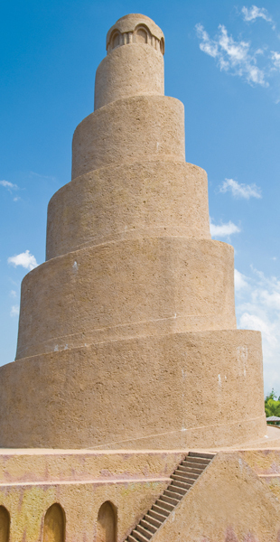After the Muslim Abbasid dynasty rose to power in the Middle East, Caliph al-Mansur decided to move his capital from Damascus to a site that was more central to his far-flung empire. The site he chose was Baghdad, a village between the Tigris and Euphrates rivers, in present-day Iraq. This location was a crossroads of trade routes connecting distant parts of the empire.
Baghdad was one of the most glorious Muslim cities. It took 100,000 architects, workers, and craftspeople four years to build the new capital. Because of its shape, people called the capital complex the “round city.” At its center were the caliph’s palace and the grand mosque. Around them were offices and the houses of court officials and army officers. A double wall with four guarded gates surrounded the inner city. Shops, markets, and residences grew up outside the wall. Soon, Baghdad was one of the world’s largest cities. Bridges, palaces, and gardens all added to its splendor. One Arab historian of the 11th century called Baghdad “a city with no equal in the world.”
The Mosque Muslims created distinctive forms of architecture. A particularly important type of building was the mosque, the Muslim house of worship.
Mosques usually have at least one minaret (tower) with a small balcony where the muezzin chants the call to prayer. In a courtyard, stands a fountain for washing before prayers. Inside the mosque is the prayer room. Worshippers sit on mats and carpets on the floor. The imam gives the sermon from a raised pulpit called the minbar. Next to the minbar is a niche in the wall that indicates the direction of prayer towards Makkah.
The minaret of the Great Mosque of Samarra has a spiral design. Muezzins climb spiral steps around the outside of the tower to the balcony at the top

Section 2 — Scholarship and Learning
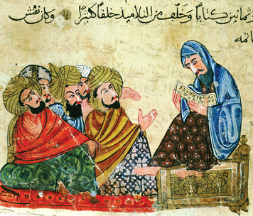
Scholarship and learning were very highly valued in Islamic culture. Muhammad is reported to have said, "The ink of scholars is more precious than the blood of martyrs."
Acceptance of the Arabic language helped promote learning. Beginning in the 8th century, Arabic became the language of scholarship and science throughout Islamic lands. A shared language and love of learning allowed scholars in Europe, North Africa, and the Middle East to exchange ideas and build on one another’s work.
Muslim rulers built schools, colleges, libraries, and other centers of learning. As you have read, one of the most important cities was Baghdad. It became a major center of learning, where Persian influences combined with the Arabic heritage of Islam. There, Caliph al-Ma’mun founded the House of Wisdom in 830. Scholars from many lands gathered there to do research and to translate texts from Greece, Persia, India, and China.
Students in Muslim schools discussed and debated philosophical ideas with their teachers
Other cities also became great centers of learning. In the 10th century, the Fatimid dynasty in Egypt built a capital, Cairo, which rivaled Baghdad. Its university became the most advanced in the Muslim world. In Cairo, the Hall of Wisdom opened in the 10th century. Scholars and ordinary people could visit its library to read books. In Spain, the Muslim capital, Cordoba, became a large and wealthy city. That city’s huge library held as many as 400,000 volumes. Buyers traveled far and wide to purchase books for its shelves.
Among the texts studied were the works of ancient Greek thinkers, such as the philosophers Plato and Aristotle. Following the example of the Greeks, Muslim philosophers used reason and logic to try to prove important truths.
Like thinkers in Europe, thinkers in the Islamic world sometimes wondered how to make reason and logical proof agree with their faith. Al–Kindi, a 9th–century Arab philosopher, tried to resolve this issue. Humans, he said, had two sources of knowledge: reason and revelation by God. People could use reason to better understand the teachings of faith. Some truths, however, could be known only through God’s word. For example, no one could prove that there would be a resurrection, or rising from the dead, on the day of judgment.

Section 3 — Science and Technology

Muslims showed an endless curiosity about the world. In fact, the Qur’an instructed them to learn more about
the world God had made. As a result, Muslims made advances in science and technology. They were particularly interested to learn how things worked.
Zoology
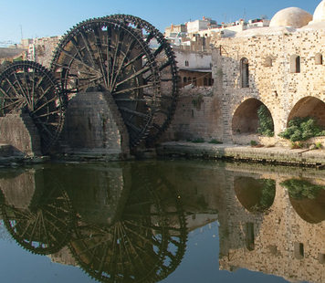A number of Muslim scholars became interested in zoology, the scientific study of animals. Some wrote
books describing the structure of animals’ bodies. Others explained how to make medicines from animals parts.
In the 800s, a scholar named al-Jahiz (AHL–jay–HEEZ) even presented theories about the evolution of animals.
Muslims also established zoological gardens, or zoos.
Astronomy
Muslim scholars did much work in the field of astronomy, the study of objects in the universe. Astronomy had many practical uses for Muslims. For example, navigational tools were improved to locate the direction of Makkah. These instruments allowed worshippers far from the holy city to pray facing in the right direction. Astronomers also figured out exact times for prayer and the length of the month of Ramadan.
Beyond such practical matters, Muslim astronomers simply wanted to learn about the universe. Some realized that Earth rotates, or turns, like a spinning top. Many questioned the accepted idea that Earth was the center of the universe, with the sun and stars traveling around it. In fact, as later astronomers proved, Earth does travel around the sun.
Irrigation and Underground Wells
Muslims made technological advances to make the most of scarce water resources. Much of the land under Muslim rule was hot and dry. Muslims restored old irrigation systems and designed new ones. They built dams
and aqueducts to provide water for households, mills, and fields. They improved existing systems of canals and underground wells. Some wells reached down 50 feet into the ground. Muslims also used water wheels to bring water up from canals and reservoirs.
The town of Hama, Syria, has 17 wooden waterwheels from medieval times. These waterwheels scoop water from the Orontes River into aqueducts, bringing it to homes and farms

Section 4 — Geography and Navigation

Another subject of study for Muslim scholars was geography. Muslim geographers examined plants and
animals in different regions. They also divided the world into climate zones.
Most educated people in medieval times believed that Earth was round, but they disagreed about Earth’s size. Muslim scientists improved on calculations made by the ancient Greeks to reach a measure of Earth’s
circumference within nine miles of its correct value.
As with all scholarship, some Muslims studied geography simply out of curiosity. But geography had
practical uses, too. For example, Muslims were able to create extremely accurate maps. A scholar in Muslim
Spain even produced a world atlas, with dozens of maps of lands in Europe, Africa, and Asia.
A work called The Book of Roads and Provinces provided maps and descriptions of the major Muslim trade routes. The Book of Countries listed useful facts about the lands under Muslim rule. From this book, travelers
could get information about a region’s physical features and water resources.
Travelers were another source of knowledge. Some travelers wrote guidebooks to help pilgrims make the journey to Makkah to fulfill the hajj. Others explored and described foreign lands, such as China and Scandinavia. One traveler wrote a 30–volume encyclopedia about all the places he had seen.
As aids to travel, Muslims used navigational instruments. Muslim scientists adapted and perfected the compass and astrolabe. Muslims probably learned about the compass from the Chinese. Compasses allow people to identify the direction in which they are traveling.
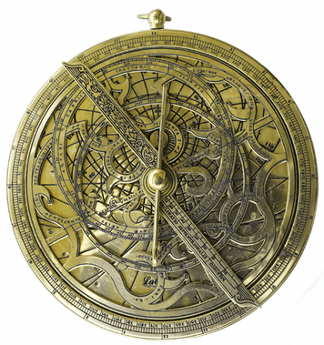The astrolabe is a device for computing time based on the location of the sun or the stars. It was probably invented much earlier by the Greeks. With this instrument, sailors at sea could use the position of objects in the sky, such as the sun or stars, to pinpoint their location by knowing how far they had traveled.
The astrolabe was a navigational tool widely used in the Islamic world and in Europe

Section 5 — Mathematics

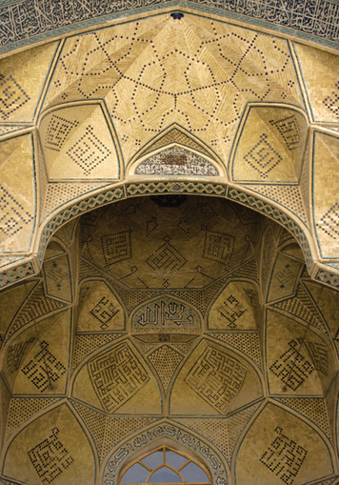Muslims greatly advanced the study of mathematics. They based their work in part on ideas from ancient Babylon, India, and Greece. For example, scholars in Baghdad’s House of Wisdom translated the works of the Greek mathematician Euclid (YOO–klid). They also translated important texts from India. Then they adapted what they learned and added their own contributions.
One of these Muslim scholars was the astronomer and mathematician al-Khwarizmi (ahl KWAR–iz-mee), who worked in the Hall of Wisdom in Cairo in the 9th century. Al-Khwarizmi is best known as “the father of algebra.”
In fact, the word algebra comes from the title of one of his books. It originated in an Arabic phrase meaning "the reunion of broken parts."
Algebra is used to solve problems involving unknown numbers. An example is
the equation 7x + 4 = 25. Using algebra, we can figure out that in this equation, x
represents 3. Al-Khwarizmi’s famous book on algebra was translated into Latin in
the 12th century. It became the most important mathematics textbook used in the universities of Europe.
The translation of another one of Al-Khwarizmi’s books helped to popularize Arabic numerals in Europe. Actually, Muslims learned this way of writing numerals, along with fractions and decimals, from Indian scholars. Arabic numerals were a big help to business and trade. Compared to earlier systems, such as Roman numerals,
they made it easier for people to do calculations and check their work. We still use Arabic numerals today.
The geometric designs in Muslim art and architecture are based on knowledge about advanced mathematical principles
Muslims also spread the Indian concept of zero. In fact, the word zero comes from an Arabic word meaning "something empty." Ancient peoples used written symbols for numbers long before anyone thought of using a symbol for zero. Yet zero is very important in calculations. (Try subtracting 2 from 2. Without using zero, how would you express the answer?) Zero also made it easier to write large numbers. For example, zero allows people
to distinguish between 123 and 1,230.

Section 6 — Medicine

Muslims made some of their most important innovations in the field of medicine. They learned a great deal from the work of ancient Greeks, Mesopotamians, and Egyptians. Then, as in other fields of study, they improved upon this earlier knowledge.
Muslim doctors established the world’s first hospitals. By the 10th century,
Baghdad had at least five hospitals. Most cities and towns also had one or two.
Many hospitals served as teaching centers for doctors in training. Anyone who
needed treatment could get it at these centers. There were also hospital caravans
that brought medical care to people in remote villages.
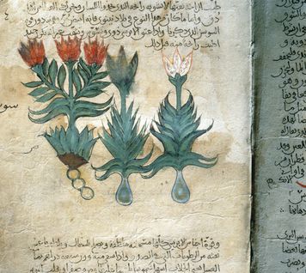Muslim hospitals had separate wards for men and women, surgical patients, and people with diseases that others could catch. Doctors treated ailments with drugs, diet, and exercise. They gave patients remedies made from herbs and other plants, animals, and minerals. Pharmacists made hundreds of medications. Some drugs dulled patients’
pain. Antiseptics (medications that fight infection) cleaned wounds. Ointments helped to heal the wounds.
Muslim doctors treated patients with herbal remedies, as well as drugs, diet, and exercise. This illustration of a lily plant is from an Arabic herbal encyclopedia of the 10th century
For some problems, surgeons performed delicate operations as a last resort. Drugs, such as opium and hemlock, put patients to sleep before operations. Muslim surgeons removed limbs, took out tumors, and cleared cataracts (cloudy spots) from the eye. After surgery, doctors used thread made from animal gut to stitch the wounds.
Muslim doctors made many discoveries and helped spread medical knowledge. For example, al–Razi, a Persian doctor, realized that infections were caused by bacteria. He also studied smallpox and measles. His work helped other doctors diagnose and treat these deadly diseases.
The Persian philosopher Ibn Sina (Avicenna) was also a great doctor. In fact, he has been called "the prince of physicians." His most important medical book, The Canon of Medicine, explored the treatment of diseases. It is one of the classics in the history of medical scholarship.
Europeans later translated Ibn Sina’s book and many other Muslim works into Latin. Medical schools then used these texts to teach their students. In this way, Muslim doctors had a major impact on European medicine.

Section 7 — Bookmaking and Literature

In the 8th century, Muslims learned the art of making paper from the Chinese. Soon, they were creating bound books. Bookmaking, in turn, encouraged the growth of Muslim literature.
Craftspeople used their talents to produce beautiful books. Bookmakers gathered the sheets of paper and sewed them into leather bindings. They illuminated the bindings and pages with designs in gold, as well as with miniature paintings.
Books became a big business in the Muslim world. In Baghdad, more than one hundred bookshops lined Papersellers’ Street. In addition to copies of the Qur’an, booksellers there
sold many volumes of poetry and prose.
Arabs had a rich heritage of storytelling and poetry. Arab poetry often honored love, praised rulers, or celebrated wit. Persians introduced epic poems, or long poems that tell a story. Prose eventually replaced poetry for recording history, special events, and traditions.
Writers also composed stories in prose.
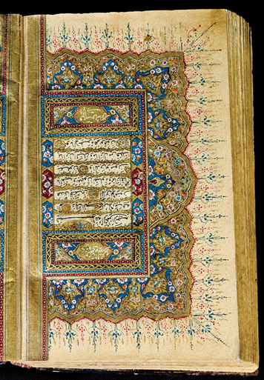One famous collection of stories is called A Thousand and One Nights. Also known as Arabian Nights, this book gathered stories that originally came from many places, including
India and Persia, as well as elsewhere in the Middle East. In the book, a wife tells her husband a new tale each night. The stories take place in Muslim cities and in places such as China, Egypt, and India. Later, a European translator added tales that were not part of the medieval Arabic collection. Among these added tales are those about Aladdin’s magic lamp, Ali Baba, and Sinbad the Sailor, which remain well known today.
As in medieval Europe, bookmaking was an art in the Muslim world. Copies of the Qur’an were written with elaborate letters and decorated in gold.
Muslim literature was enriched by Sufism, or Islamic mysticism. This type of religious practice involves intense personal experiences of God, rather than routine performance of rituals. Sufis longed to draw close to God in their everyday lives. One way to express their love and devotion was through poetry filled with vivid images and beautiful language. Rabi’a, a poet of the 8th century, shared her feelings in this verse: "But your door is open to those who call upon you. My Lord, each lover is now alone with his beloved. And I am alone with Thee."
A 13th-century Sufi poet, Rumi, had an enormous influence on Islamic mysticism. Rumi wrote a long religious poem in Persian that filled six volumes. Pilgrims still travel to his tomb in Turkey.

Section 8 — Art and Recreation

Textiles
Manufactured fabrics, or textiles, had long been important to Arab people as practical items and as trade goods. Muslims in medieval times brought great artistry to making textiles. Weavers wove wool, linen, silk, and cotton into cloth, and then dyed it in vivid colors. Valuable cloths sometimes featured long bands of inscriptions or designs showing important events. Fabrics were also embroidered, often with gold thread.
As is still often the case today, clothes showed rank, and served as status symbols in the Muslim world. The caliph and his court wore robes made of the most valuable materials. Fine textiles served as awnings and carpets in the royal palace.
Polo
Muslims first learned about the game of polo from the Persians. Polo is a
sport in which teams on horseback use mallets (long wooden hammers) to strike a ball through a goal. Muslims looked at horses as status symbols, and polo quickly became popular among the wealthy. For example, Abbasid rulers
began to raise champion Arabian horses to play polo. Muslims adapted and
refined the game of polo. Today, the game is enjoyed all over the world.
Chess
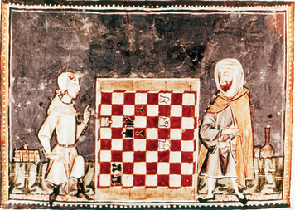The game of chess was probably invented in India. Persians introduced
the game to the Muslim world in the mid-600s. It quickly became popular at
all levels of society. Caliphs invited chess champions, even women and slaves,
to their palaces to play in matches. Players enjoyed the intellectual challenge that chess presented.
This illustration of two men playing chess is from a medieval book. The board is shown flipped up so that readers could analyze the players' positions in the game.
Chess is a battle of wits in which players move pieces on a board according to complex rules. Each player commands a small army of pieces, one of which is the king. The goal is to checkmate the opponent’s king. Checkmate means that the king cannot move without being captured.
As with polo, Muslims adapted and improved the game of chess. They spread it across Muslim lands and introduced it to Europe. Chess remains one of the world’s most popular board games.

