Sociology
Chapter One Theory Power Point
Guided Notes

The Sociological Perspective
“The Fish in the Fishbowl Cannot see the water”
The importance of perspective:
________________________________________________________________________________________.

Experiences are internalized and become part of ______________________________________.
Sociology and other Sciences
- _______________________ incorporates systematic methods that are used to study the social and natural worlds, as well as the knowledge obtained by those sciences.

- _______________________ is the “scientific study of society and human behavior.”

- _______________________attempt to comprehend, explain, and predict events in our natural environment, like biology, geology, chemistry and physics.
Social Sciences
- Social sciences seek to ___________________________________ the social world.

- Political science focuses on _____________________ or _____________________.

- ___________________________ analyzes the production, distribution, and allocation of material goods and services of a society.

- ____________________________ primarily focuses on preliterate peoples and seeks to
_________________________ ____.
- Psychology concentrates on ____________________________________________________.

- Sociology looks at all ______________________________, and focuses on industrialized societies, and looks at external factors that influence people.
Sociology and the other Sciences continued…
- The goals of science include:

- ___________________________________ why something happens.

- Makes ______________________________ beyond individual cases.

- Looks for ____________________________ in society.

- ____________________ and specifies what will happen in the ______________________________.
*This can be confusing because we try not to stereotype, but we do try to find patterns
The Development of Sociology
Sociology developed in the mid-nineteenth century as a result of three factors:

- Social upheaval in Europe resulting from the _______________________________________.

- ______________________________conquering other nations exposed people to differing cultures.

- The success of the _____________________________________, creating a desire for answers about the social world as well.
The Founding Fathers
- Auguste Comte
- Herbert Spencer
- Max Weber
- Carl Marx
- Robert Merton
- Emile Durkheim

The Father of Sociology

- _______________________________

- Coined the term sociology.

- ________________________: the idea that we should apply the scientific method to the social world.

- Sat on the couch!!!

- ________________________ Theorist
Did Darwin Plagiarize?
- Herbert Spencer coined the term _________________________________________.

- Became known for ________________________________, the idea that society evolves (changes).

- Yes, this is where Darwin got his ideas!!!
Functional Theorist
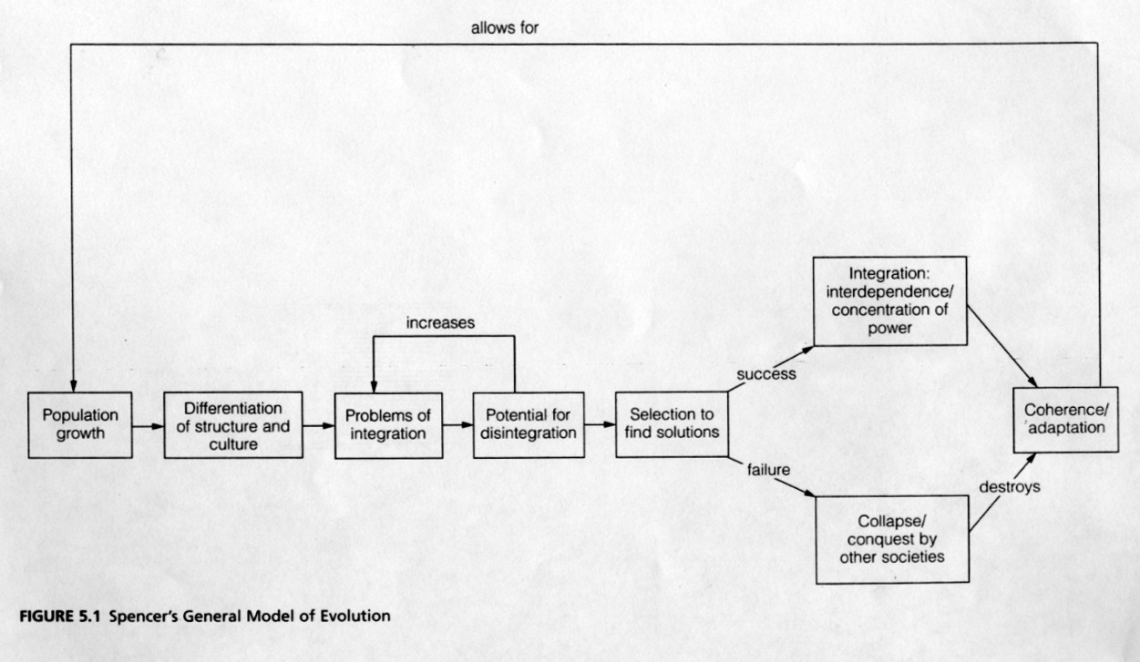

Shouldn’t Psychologists Study Suicide?
Emile Durkheim
- Used his study of suicide to investigate how individual behavior is shaped by social integration, and how

_______________________________ someone is to the entire _________________________________.

- Suggested new social groups be created to link the _________________ and the __________________.

- Functional Theorist - Anomie- Durkheim’s term for a condition in society in which people become detached, cut loose from the norms that usually guide their behavior.
King Karl is rolling over in his grave
Karl Marx
- Did work that formed the basis for the _____________________________________________ perspective.

- Believed that class conflict was the key to ___________________________________________ history.
Conflict Theory
Not responsible for “communism” as we know it.
What do Religion and money have to do with one another?
Max Weber
1. Symbolic Interactionist
2. Challenged Marx by applying historical data to test the proposition that the protestant ethic was a
necessary cause for the rise of _______________________________.
The Role of values in Social Research
- Weber advocated a __________________________ sociology, the idea that a sociologists personal

values or biases should not _______________________________________________ social research.

- _____________________________________________ should be a hallmark of sociological research.
- Although this is a proper goal, no one can ___________________________________ values entirely.

- Do you think that sociology can be values free?

- Can a teacher teach values free?

Verstehen and Social Facts
- Verstehen is understanding behavior by looking at the ______________________ meanings that people attach to their own behavior.

- ________________________ a situation because maybe you have some ___________________ with it.

- Durkheim defined _____________________________ as patterns of behavior that characterize a group, reflecting underlying conditions of society.
Sexism in Early Sociology
- Since most women in the 1800s were expected to remain housebound, few of them had the opportunity

to help shape the beginnings of __________________________________________________________.
Harriet Martineau
- Pushed back the barriers of sexism.

- Studied __________________________________ in Great Britain and the United States.

- Published __________________________, yet her work was largely ignored until recently.
Sociology in North America
The first U.S. sociology department was at the University of Chicago.
- Albion Small founded that department and the American Journal of Sociology
Other early programs include the University of Chicago. Sociologists included Robert E. Park, Ernest Burgess, and George Herbert Mead
Breaking down the barriers
- Jane Addams
- Was one of several U.S. women contributing to the early development of sociology.
- Founded Chicago’s Hull- House
- Published a book ______________________________ each year between the powerful and powerless.
The first African American in Sociology
- W.E.B. Du Bois
  - Was the first African American to earn a Ph.D. at Harvard.

  - Conducted research on ____________________________________ in the United States.

  - Published a book on race relations each year between 1896 and 1914.

  - Helped found the ___________________________________________.
And the Others……
- Other sociologists who made outstanding contributions include…

- ___________________________, who focused on how the part of society harmoniously work together.

- ____________________________, who stressed that sociologists need to develop middle-range theories, explanations of behavior that go beyond the particular observation or research but avoid sweeping generalizations that attempt to account for everything.

- C. Wright Mills, who urged sociologists to get back to ____________________________________.
Who will you really need to know?

- __________________________________________: Father of Sociology

- Durkheim: _________________________________________________

- _________________________________: The father of the conflict theory

- Max Weber: Studied ___________________________ and the _________________________________.

- _____________________________________: Manifest and Latent Functions

I have a Theory on that
- Theory is a _____________________ about how some parts of the ______________________________.

- How two or more facts ______________ to each other.

- There are ______________ Major Sociological Perspectives
- _______________________________ Interactionist Perspective.

- ________________________________ Theory.

- _________________________________ Theory.
What do you mean?
- Symbolic interactionism states that...
- Society is composed of __________________________________________.
- People use symbols to…
  - Establish ________________________ and ________________________.

  - ___________________________ actions.

  - Develop a _________________ of the ___________________ and the ____________________.
Let’s shake things up a bit
Functional analysis states that…
  - Society is a system composed of ________________________________ parts.

  - Each ______________________________ contributes to society’s equilibrium.

  - Functions can be either _____________________ or ____________________________.
  - See Merton
  - Example: how one event __________________ another element of _______________________.
Robert Merton
Manifest Function
- The __________________________________ consequences of a _______________________________.

Latent Function
- __________________________________ consequences of a __________________________________.

In the Schools
Manifest Functions:
- _________________________________________________
- Skills for life
Latent functions:
- ___________________________________________________
- Values and norms for the generation
Dysfunctions
Unintended consequences with a ___________________________________ outcome.
Conflict Theory
- Conflict Theory- A theoretical framework in which society is composed groups ___________________
for _________________________________.

- The greater the ___________________________ in the distribution of resources, the greater the level of
social __________________________________ and _________________________________________.

Key Words
- ________________________: power that people consider legitimate.

- Bourgeoisie- Karl Marx’s term for the people who ____________________________________________.

- _____________________ conflict: Marx’s term for the _____________________________ between the proletariat and the bourgeoisie
At the present
- You need a ____________________ of all ___________________ perspectives to __________________ society.

- _____________________________________________ is not dominated by one theoretical orientation.

- Relatively few sociologists are ___________________________________________________________.

- Sociologists are employed in teaching, the government, the private sector and other fields, CIA, Forensic Sciences, medicines...
The levels of analysis in sociology are…
The macro level, which examines ________________________________________________________________.
- Functional Theory
- Conflict Theory
  - Examples Include:
    - Economic Systems
    - Racism
    - Global Terrorism

The ____________________________________________ level, which examines small-scale patterns of society
- Symbolic Interactionist Theory
  - _____________________________ Biases

  - _____________________________ Customs

Combining the Theoretical Perspectives
- Each perspective provides a _________________________ and often sharply

_____________________________ picture of the world.

- Sociologists use all three because no one theory or level of analysis encompasses all of _____________.
Applied and Clinical Sociology
There have been three phases in the development of sociology…
- The concern with making the world a _____________________________________________.

- The establishment of sociology as a respected field of knowledge.

- The current phase: the merging of sociological ___________________ and practical ________________.
Three different emphases now mark the work of sociologists.

- “Pure” sociology makes ____________________________________ about life in human groups,

whereas applied sociology tries to use sociology to __________________________________________.

- Applied sociologists study a ______________________________ or __________________________ and

_______________________________changes.

- ___________________ Sociology- the direct involvement of sociologists in bringing about social change.
Just two more things
- _______________________________________________ those things that everyone knows are true.

- Common Sense is often proven __________________________________________ by social research.

- _______________________________a statement that goes beyond the individual case and is applied to a broader group situation

