Chapter 25: Forces for Independence and Revolution in Asia
Essential Question: How did popular movements transform India and China after World War II?

Section 1 — Introduction
In April 1930, Mohandas Gandhi, a small thin man of 61, led a group of Indians to a seashore on India’s west coast. There, as authorities watched, he and the others walked along the shoreline, picking up handfuls of natural sea salt. With this simple and defiant act, they intentionally broke the law. Salt was heavily taxed in British India. It was illegal to produce or sell salt without paying the tax. This deprived the great majority of Indians of needed salt because they were poor. By picking up the sea salt, Gandhi and his group were technically “producing” salt.
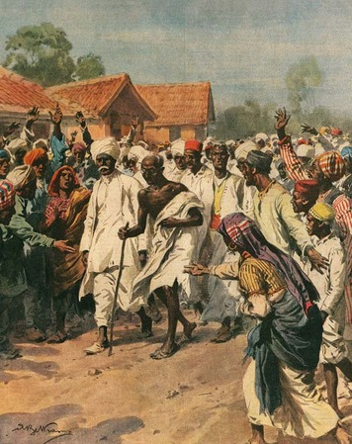
Gandhi and his supporters protested unfair salt taxes on the Salt March. De Agostini Picture Library/De Agostini/Getty Images
The authorities did not arrest Gandhi that day. However, he was arrested several weeks later after announcing a march on a nearby salt factory. The march took place anyway. On May 21, 1930, police attacked some 2,500 peaceful protesters as they approached the factory gate. The protesters did not fight back, flee, or even try to block the blows. They knew that their non-violent resistance would help draw attention to how unfairly they were being treated by the British.
Meanwhile, in nearby China, 30-year-old revolutionary leader Mao Zedong had also acted against his government. Like Gandhi, he wanted to replace a government he had once supported. However, Mao did not share Gandhi’s belief in nonviolent protest. He would soon spearhead a long civil war that would cost millions of lives and make China a communist nation.
India and China have histories that are as similar as they are different. Each civilization has existed for thousands of years. Over that time, its people have experienced rule by powerful local leaders or distant emperors as well as invasion, conquest, or other domination by outsiders. By the mid-1800s, India and much of China were under European control. It is here that their histories differ. In the mid-1800s, India was a colonial possession of Great Britain, while China continued to be ruled by its emperor. In the 1900s, however, that all changed.

Themes
Cultural Interaction Religious tensions and differing ideologies have created conflict and have been forces for change throughout history.
Political Systems The spirit of nationalism has encouraged revolts, revolutions, and other unrest that have affected nations’ political structures and altered their forms of government.
Human-Environment Interaction Wars and other conflicts have prompted mass migrations that changed human characteristics of regions and nations.

Section 2 — The British in India
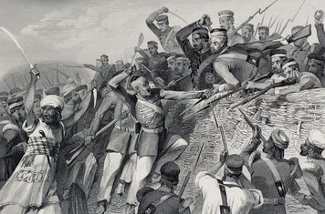
This engraving from 1858 shows Indian rebels attacking the British artillery battery in the city of Lucknow. In 1857, sepoy soldiers who were trained and led by British officers revolted against the British. Rural peasants, maharajas, and the Indian emperor also joined the rebellion. Duncan Walker
The British presence in India began in 1612 when the East India Company opened a trading post on India’s northwest coast. By 1690, the company had two more posts on India’s east coast. Three of India’s most important cities developed from these trading centers—Bombay (now Mumbai), Madras (now Chennai), and Calcutta (now Kolkata). The company bought such raw materials as a blue dye known as indigo, saltpeter (used in making gunpowder), sugar, salt, and textiles in India and took them back to Europe for sale. The French, Dutch, and Portuguese also had trading posts in India and engaged in a similar trade.
The East India Company As India’s Mughal dynasty weakened in the late 1600s, the East India Company turned its trading posts into forts. Sepoys—Indian soldiers trained and led by British officers—protected these forts. The company gained the favor of the Mughal emperors, who sought to benefit from its military and naval power. Company officials also allied with local rulers and sometimes used the sepoys to settle regional power struggles.
These practices allowed the company to extend its influence far into India’s interior. British victories in Europe’s wars in the 1700s, which also caused Europeans in India to fight, further increased the company’s power. Most of the French, Dutch, and Portuguese traders were gone by the early 1800s. By the 1850s, the East India Company was more powerful than the emperor himself and it controlled some 60 percent of India. The rest was ruled by more than 500 Muslim, Sikh, and Hindu princes called maharajas.
The East India Company developed a large network of Indian merchants to obtain the products the company desired. However, company officials showed little respect for India’s rich and ancient culture. Instead, the British saw themselves as the bearers of civilization. English became the official language in regions the company controlled. Upper-class Indians were offered an English-style education so they might help the British deal with India’s masses. Conservative Hindu and Muslim leaders resented such policies, as well as the Christian missionaries who arrived. Many Indians thought that Western culture and religion were being forced on them. Some were also troubled by the railroads and other technology the British introduced.
Tensions came to a head in 1857 when sepoys in northern India rose in revolt against their British officers. They were soon joined by rural peasants and many others unhappy with the British presence in India. The rebels also included the emperor and maharajas who had lost territory to the East India Company. Fighting went on for more than a year. Some 10,000 British troops finally put down the revolt.
The British Raj The 1857 uprising brought the East India Company’s power to an end. In August 1858, Parliament transferred the rule of India from the company to Britain’s monarch. The British government pledged to respect the rights of the maharajas to the territories they ruled. More than 560 such regions remained politically independent throughout the entire 90 years of the British Raj, or “rule.”
During the Raj, India’s government became the world’s largest imperial bureaucracy. A viceroy appointed from Britain ruled the colony. He was assisted by appointed councils that issued laws and helped to carry them out. An appointed governor in each of the colony’s provinces managed district officials who formed the lower levels of the Indian Civil Service. These officeholders were nearly all British. Indians, including those with English educations, were rarely selected to fill these positions.
As more and more British arrived in the colony, a separate British society emerged. Although segregation did not officially exist under law, an informal type of segregation took hold. The British lived in their own communities and moved in social circles that were closed to Indians regardless of their education, abilities, or class.
Some Britons bought rural lands and became the landlords of the peasants who lived there. They made these peasants grow tea, coffee, and other commercial crops for export overseas instead of food for local populations. Parts of India experienced famines because of these policies. Meanwhile, Britain’s industries increased their exports to India.
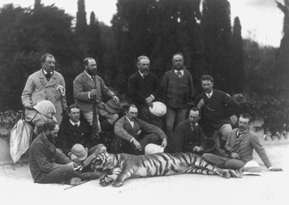
After the 1857 rebellion, Great Britain transferred rule of India from the East India Company to the British monarch. In 1875, the Prince of Wales completed a tour of India. In this photograph, the Prince (holding rifle) poses with his hunting party and the Bengal tiger they have killed. Library of Congress
Many of these products were less expensive than Indian-made goods. India’s traditional textile industry and other industries suffered as a result, especially because the British banned Indian textiles from their home market while allowing their relatively cheap British textiles to flood the Indian market tariff free. At the same time, India’s natural resources were being depleted to meet the demands of British industry.
In 1885, delegates from across British India met to found the Indian National Congress. They were mostly Western-educated Indian lawyers, teachers, and other professionals. Nearly 75 percent were Hindus and only 2 were Muslims—a make-up that reflected the tensions between India’s Hindu majority and its largest religious minority. The Congress passed resolutions demanding economic reforms and more participation by Indians in their government. These demands had popular appeal. By 1888, more than 1,200 delegates were attending the Congress’s annual meetings.
The British did bring Indians into local governments in the late 1800s and onto the viceroy’s legislative council. However, very few became part of the Indian Civil Service—the officials that Britain called the “steel frame” of its rule.

Section 3 — Independence for India
The first large-scale resistance to the British Raj occurred in response to Britain's division of Bengal into two separate provinces in 1905. Bengal was a region in northeastern India populated by 85 million people. The British had long considered the province too large to govern effectively. However, English-educated Bengalis saw the split as a destruction of their beloved homeland and an attempt to reduce Hindu power. The fact that one of the new provinces contained a Muslim majority inflamed their discontent. To protest these developments, they organized a boycott of British goods. The Indian National Congress soon spread the boycott throughout India. Nationalist protesters took to the streets in cities across India. Some of these demonstrations turned into violent riots.
The intensity of the Hindu reaction concerned India’s Muslims, many of whom favored the division of Bengal. Especially troubling was the Hindus claim that Bengal was a Hindu land. To protect Muslim rights and promote loyalty to the British, Muslim elites formed the All-India Muslim League in 1906. They hoped their organization would balance the power of the Indian National Congress, which Hindus dominated.
In 1912, British officials reversed course and reunited Bengal. The action restored the power and prestige of the Indian National Congress, which had been weakened by its failure to undo the split. However, Muslim leaders felt betrayed. They began to question their support of the British and the status of Muslims in India.
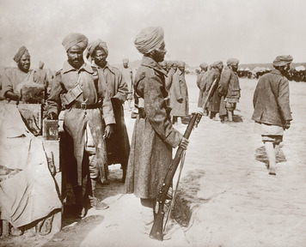
About 1.3 million Indian soldiers served in World War I. The soldiers in this photograph served on the western front in France. Indians hoped that the British would reward their service with greater independence after the war, but they were disappointed when few changes took place. Everett Collection Inc / Alamy
India in World War I Tensions were temporarily forgotten as World War I began in 1914. More than 300,000 troops of the British Indian Army were rushed to overseas battlefields. The British Indian Army reinforced Allied troops on Europe’s Western Front and fought against Ottoman forces in the Middle East. India’s maharajas volunteered men and money to the war effort. Although some Indian Muslims hesitated about waging war against the Muslim Ottoman Empire, by the war’s end in 1918, some 1.3 million Indians had served on every major front.
As the fighting raged, Britain promised to make major political changes in India after the war. This led the Indian National Congress and the Muslim League to form a temporary alliance. They believed that Britain might reward India’s loyalty by offering home rule or even complete independence and they wanted to be united in dealing with any British reforms. However, despite Britain’s promises, little positive change took place. British officials returned, and they ousted Indians who had taken their place during the war. Indian soldiers, who had been treated as valuable allies during the war, became “natives” again.
Massacre at Amritsar In 1919, the viceroy’s legislative council passed a series of laws—which every Indian council member opposed—extending wartime measures that had limited personal rights and freedoms. Intended to suppress political unrest, the laws allowed the government to shut down newspapers during emergencies and to jail political activists without trial. A Congress member, Mohandas Gandhi, called for a general strike to protest these laws and launched a nationwide movement for its repeal.
The strongest protest came from Punjab, a northwestern province that had provided nearly half of India’s combat troops during the war. In April, two nationalist leaders were arrested at a huge protest rally in the city of Amritsar. When the protesters demanded their leaders’ release, British troops fired on them. Several protesters were wounded or killed. The enraged mob rioted, destroying British property and killing several Britons. The British responded by banning further public assemblies.
Despite the ban, some 10,000 unarmed Indian men, women, and children gathered in a walled square on April 13, 1919, for a peaceful protest. A British general placed soldiers at the entranceway and ordered them to fire on the crowd. There was no escaping the terror. Several minutes and some 1,650 rounds of ammunition later, nearly 400 protesters lay dead. More than 1,000 others were wounded.
The Amritsar Massacre shocked all of India and raised Gandhi to leadership in the Indian National Congress. The general was removed from command, but the British did not severely punish him. Gandhi called this response a “whitewash.” British leaders finally made some minor reforms that allowed Indians to be elected to provincial councils. It was not enough. The Congress adopted a policy of resistance to British rule. Millions of other Indians suddenly became nationalists. After years of patiently accepting British rule while they waited for change, they now wanted Britain out of India.
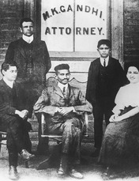
When Mohandas Gandhi found few opportunities for practicing law in India, he traveled to South Africa, where he worked for an Indian law firm. This 1903 photo shows Gandhi, seated in the center of the image, with fellow employees of the law firm. The racial prejudice Gandhi encountered in South Africa spurred him to begin a life of political activism. Gamma-Keystone via Getty Images
Mohandas Gandhi “I can no longer retain affection for a government so evilly manned as it is nowadays,” Gandhi wrote in 1920. He made it his mission to change that situation. Gandhi’s methods for resisting British rule made him one of the most influential political figures of the twentieth century.
Gandhi was born in 1869, the son of a high official in a small princely Hindu state in western India. At age 18, he went to Britain to study law. Returning to India, he found few opportunities for success as a lawyer. So in 1893, he went to work for an Indian firm in South Africa. There, his legal training and personal encounters with racial prejudice caused him to lead a long struggle to gain equal rights for South Africa’s Indian minority.
Returning to India in 1914, Gandhi soon became a member of the Indian National Congress. However, he refused to take part in any anti-British activities until 1919. But the insensitive reaction of the British to the Amritsar Massacre drove him to launch a resistance movement that employed tactics he had used in South Africa.
Gandhi’s Satyagraha Movement In 1920, Gandhi announced a campaign of massive and widespread nonviolent resistance and noncooperation with the British. He called on Indians to boycott all British goods, businesses, schools, courts, and elections. He urged them to refuse any titles, honors, or offices the British offered—and, if all else failed, to refuse to pay British taxes. He claimed that only the total withdrawal of support for British rule would bring freedom for India.
Some Indian leaders questioned Gandhi’s tactics. They declared that a violent uprising was needed. Gandhi rejected the use of violence. However, his experience in South Africa had taught him the value of being the target of it. The small Indian population in South Africa had faced a seemingly impossible task in its struggle with the powerful and oppressive white government. Yet the thousands of Indians willing to accept jail or beatings for refusing to obey laws or end strikes caused their movement to succeed. It was a terrible ordeal for them, but it had brought attention to an unjust government.
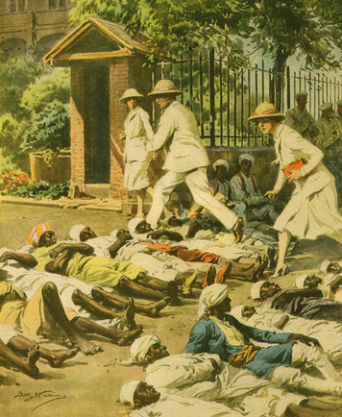
Gandhi’s satyagraha (truth-force) movement rejected violence and urged Indians to practice nonviolent civil disobedience. This illustration shows one type of peaceful demonstration that satyagraha participants used to draw attention to their cause. The Art Archive / Collection Dagli Orti
Indians were not a minority in India, of course, but its British government was just as powerful as the one in South Africa. Gandhi claimed that millions of Indians engaged in peaceful civil disobedience would bring Britain’s colonial officials to their knees. He urged his followers to use only the weapons of satya (truth) and ahisma (nonviolence or noninjury) against their British oppressors. In time, he stopped using the term “passive resistance” to describe his strategy and adopted the more accurate satyagraha (truth-force) instead. For Gandhi, satyagraha blended politics with deeply-held Hindu beliefs. Many of his followers viewed him as a guru, or spiritual teacher. They called him Mahatma, or “Great Soul.”
Resistance, Conflict, and Compromise Gandhi’s noncooperation movement was an immediate success. Millions of Indian voters boycotted the provincial elections of 1920. Congress members who were running for seats on provincial councils withdrew their candidacies. By 1922, widespread civil disobedience had put some 60,000 Indians in prison. Yet British policy stayed the same. So Gandhi decided to use his most powerful weapon—a boycott on payment of taxes. However, before he could organize this final boycott, some of his followers in northern India trapped and killed 22 officers inside their police station. Shocked and disappointed by this event, he ended the noncooperation campaign.
Sensing that Gandhi was losing support, the British arrested him. During the two years he was in jail, his support did slip. Some members of Congress formed a political party that took part in the 1923 elections and called for home rule. When he regained his freedom in 1924, Gandhi found that much had changed. Radical young Congress members charged that he had betrayed the independence movement by ending the satyagraha. They were calling for armed rebellion against Britain. Worst of all, the unity between Hindus and Muslims that existed during the satyagraha had dissolved. Tired and discouraged, Gandhi withdrew from politics.
In 1927, the British government formed a commission to suggest reforms for India’s government. Outraged that this commission contained no Indians, Gandhi returned to public life. He again became head of the Indian National Congress. In 1928, the Congress demanded the Britain grant India dominion status within a year. When this demand was not met, Gandhi launched a second satyagraha. Its high point was the famous Salt March of 1930. This protest of a minor tax on salt shocked both the British and the Congress. But it was a stroke of genius.
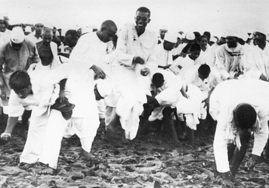
In this photo, Gandhi and his followers harvest sand to boil for salt, in violation of British law. The Salt March inspired civil disobedience throughout India. It also created sympathy around the world for the cause of Indian nationalism. Mansell/Time & Life Pictures/Getty Images
The Salt March began in April 1930, when Gandhi led a group of followers on a 240-mile walk from his home to the sea. Hundreds more joined the march as it passed through rural villages. Images of this frail man striding forward, staff in hand, to confront the British over a tax on a basic human need won Gandhi worldwide attention and support. The brutality of the British response to this nonviolent action, which for the first time included women, also affected world opinion.
Besides women, the second satyagraha included other groups who had not taken part in the earlier campaign. For the first time, large numbers of people in central and south India gave the movement their support. The civil disobedience inspired by the Salt March resulted in 60,000 arrests in 1931. In one three-month period in 1932, some 40,000 Indians were arrested. Many of those jailed, including Gandhi himself, remained there for up to two years. After his release, Gandhi again retired from politics and resigned from the Indian National Congress. Jawaharlal Nehru, who had been elected President of the Congress in 1929, succeeded him as its head.
Ominously, Muslims’ support for Gandhi’s first satyagraha was missing in his second. One reason was the riots between Hindus and Muslims that engulfed every major northern Indian city in 1924. However, Muslim leaders had also become concerned about Hindu domination of the independence movement. They worried about being shut out of any negotiations with the British that might shape the future of India’s government. By 1930, some Muslims had begun to call for a separate nation for their minority community.
The Muslim League did not join these calls until 1940. It still hoped to work with the Indian National Congress to create one independent India. However, in 1935 Britain increased Indians’ power in their provincial governments. In the elections that followed this reform, the Indian National Congress—which had reorganized as a political party, the Congress Party—won control of nearly every province in India. It rejected a coalition with the Muslim League as unneeded. Only two powers existed in India, Nehru said—the Congress and the British. The Muslim League responded by working hard to build its popularity and power among Muslims. By World War II, the divisions were in place that split British India after the war.
War, Partition, and Independence In September 1939, Britain issued India’s declaration of war on Germany without even consulting Indian leaders. The Congress Party’s provincial governments resigned in protest. The party demanded immediate independence in return for India’s support in the war. A renewed civil disobedience campaign resulted in the arrest of 20,000 Congress members by 1941.
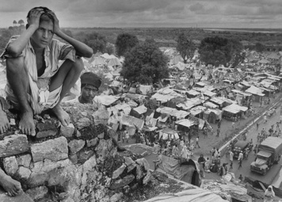
The partition of British India in 1947 resulted in mass migration as people fled their homes to settle in the state associated with their own religious group. This image from 1947 shows a homeless boy on a hill above a large refugee camp that sprung up to house dislocated migrants. Margaret Bourke-White/Time & Life Pictures/Getty Images
In 1942, with Japanese troops threatening British Asia, Britain countered with an offer of independence after the war. Suspicious of British promises, Congress rejected the compromise. It began a violent campaign to drive the British from India. British troops crushed the uprising. Authorities cracked down by arresting some 60,000 more Congress members, including its entire leadership, and imprisoning them for the rest of the war.
These events delighted the Muslim League, which supported the war in every way possible. As the government’s split with Congress widened, its ties with the League grew closer. The Muslim League asked the British to include a separate nation for Muslims in any plan for India’s independence.
On August 15, 1947, British India became the independent nations of India and Pakistan. Some 15 million people—Hindus, Muslims, and members of other groups—fled their homes in order to be on the “right” side of the border. As many as a million others were slaughtered in the religious violence that accompanied that migration.

Section 4 — Reform and Revolution in China
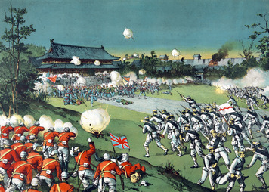
In June 1900, Boxers murdered the German foreign minister in Beijing. Many other westerners and Chinese Christians were besieged in the city. In August, a coalition of 19,000 foreign troops arrived in Beijing to crush the Boxer forces. This Japanese print from 1900 shows allied forces driving Boxers away from the imperial palace in Beijing. Library of Congress
As Indian leaders worked to reform British rule in India, Chinese reformers sought to bring change to their nation and its government. In 1850, radicals tried to end the Qing (ching) dynasty whose emperors had ruled China for more than 200 years. The resulting Taiping Rebellion turned into a long civil war. Chinese troops finally defeated the rebels in 1864. The rebellion cost some 20 million lives, according to conservative estimates, and it seriously weakened the Qing dynasty.
Reform Movements Lead to Power Struggles The Self-Strengthening Movement, which began in the 1860s, tried to establish modern industries and otherwise reform China according to Western ideas. However, conservative Qing rulers opposed China’s Westernization and disliked the spheres of influence that Western nations established in China by late 1800s. However, the Qing were too weak to resist this economic imperialism. China was also too weak to prevent Japan from seizing Korea in the Sino-Japanese War of 1894–95 and taking control of part of Manchuria.
China’s defeat in the Sino-Japanese War increased the calls for reform. When the emperor began to make some of these changes, he angered the conservative empress dowager (the widow of a dead emperor) Cixi (tsoo-SHEE). In 1898, Chinese officials loyal to Cixi removed the emperor. She took power and reversed his reforms.
Cixi supported Chinese leaders who encouraged an uprising against foreigners called the Boxer Rebellion. Bands of Boxers roamed the countryside in 1899 attacking Christian missionaries and destroying foreign-owned mines and other property. Many foreigners fled to Beijing, China’s capital. In August 1900, some 19,000 troops sent to Beijing by Western nations defeated Chinese forces and freed the foreigners the Boxers had trapped there. The Boxers were Buddhist mystics who believed that they were immune to bullets, which proved not to be the case. A coalition of British, French, and other European forces crushed their rebellion.
After the Boxer Rebellion failed, Cixi began making some of the reforms she had reversed in 1898. However, it was too late. The Qing dynasty had been hopelessly weakened. Protests and revolts broke out across China. Cixi died in 1908. Just before her death, she had the emperor she replaced in 1898 killed by poison. This left his three-year-old nephew Puyi to be emperor. A regent ruled until 1912, when revolution forced Puyi from the throne. Puyi was China’s last emperor. His overthrow ended 267 years of Qing rule and a form of government more than 2,000 years old.
The Revolution of 1911 Although the Boxer Rebellion failed to drive foreigners from China, it strengthened Chinese nationalism. This was especially true for young and well-educated Chinese. When the reform movement also failed, many of these Chinese came to believe that revolution was the only solution. They wanted to replace China’s old ruling system with a republican form of government.
The revolutionaries were led by Sun Yat-sen, a Western-educated medical doctor from South China Although he had no political training, Sun was troubled by the Qing rulers’ resistance to modernizing China. Following China’s defeat in the Sino-Japanese War, he called for a revolt in Canton (now Guangzhou), the capital of his home province. When the plot collapsed, Sun fled China. He spent the next 16 years living in Europe, Japan, and the United States. During his exile, Sun collected funds from Chinese overseas to organize several more uprisings in China. They all failed.
Another revolt occurred in 1911, when army units near Beijing rebelled against the Qing. As the revolt spread, Sun’s supporters joined it. By November, 15 of China’s 24 provinces had declared independence from Qing rule. Sun returned to China and was named president of a new Chinese republic. However, Yuan Shikai, the commander of China’s army, was already acting as China’s leader. To avoid civil war, Sun stepped aside. In February 1912, Yuan became the first president of the Republic of China.

Section 5 — China’s Civil War
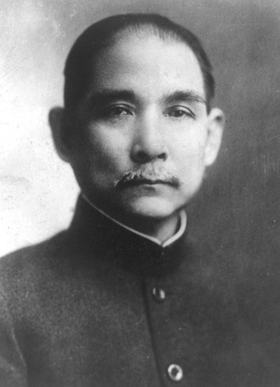
Sun Yat-sen was a Western-educated doctor who led a revolutionary movement in China. He came to believe that reform within the existing system was not possible, and that China’s imperial government should be overthrown and replaced with a republic. Library of Congress
Sun Yat-sen, leader of China’s 1911 revolution, is known as the father of modern China. He hoped to build a nation based on what he called the Three Principles of the People—nationalism, democracy, and socialism. However, the new republic’s first president, Yuan Shikai, was mainly interested in increasing his power. To counter Yuan, Sun joined with other former revolutionaries to found a new political party—the Kuomintang (KMT) or Nationalist Party.
The Republic’s Early Struggles Elections in February 1913 gave the Nationalist Party a majority of the seats in China’s new parliament. Yuan responded by having the party’s leader killed. When a revolt against Yuan failed in the summer of 1913, Sun and its other leaders fled to Japan. In November, Yuan banned the Nationalists and removed its members from parliament. In 1914, he dissolved parliament and issued a new constitution that made him president for life.
Yuan declared China neutral when World War I began in August 1914. However, Japan, which fought for the Allies, seized the German sphere of influence in Shandong, in eastern China. Japan also forced Yuan to grant it a sphere of influence in Manchuria. When Yuan appealed to the United States and other Western powers for help, they refused to get involved.
Perhaps unwisely, Yuan chose this moment of humiliation to announce his plans to make himself emperor. Rebellions broke out all over China. Japan secretly provided arms and money to Sun and other leaders to aid these revolts. In several provinces, warlords declared their independence of the central government in Beijing. After Yuan fell ill and died in June 1916, alliances of warlords fought for control of that government. Sun Yat-sen and warlords in southern China organized a rival government in 1917. Its repeated efforts to control all of China plunged China into a long civil war.
Hoping to regain Shandong, both governments declared war on Germany in 1917. However, the Paris Peace Conference following World War I let Japan keep German holdings in China. Some Chinese nationalists blamed the Beijing government for this failure. On May 4, 1919, a massive student protest erupted in Beijing. The calls for change that followed became known as the May Fourth Movement. They ranged from the westernization of China to the establishment of socialism. The May Fourth Movement, along with China’s split between the two rival governments, soon sent the nation down a new revolutionary path.
China’s Nationalist Government In October 1919, Sun Yat-sen restarted the Nationalist Party. He hoped that a democratic political party in the south would weaken the warlords in Beijing, which the West recognized as China’s legal government. In 1921, Sun became president of China’s southern government. Because of its domination by the KMT, that government became known as the Nationalist government.
Until his death in 1925, Sun devoted himself to reuniting China under Nationalist rule. However, his appeals to the Western democracies for aid were ignored. So Sun turned to the Soviet Union, which had recently achieved its own revolution. In 1923, Soviet advisers arrived to help Sun unite China. The Chinese Communist Party (CCP), founded with Soviet help by members of the May Fourth Movement in 1921, was instructed to cooperate with the KMT. CCP members joined the KMT, although they never lost their identity as Communists.
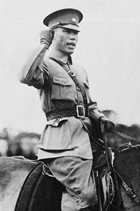
Chiang Kai-Shek traveled to Russia to learn Western military strategy from the Soviets. As commander of the Nationalist army, Chiang helped the Nationalists gain control of a most of China by 1927. DIZ Muenchen GmbH, Sueddeutsche Zeitung Photo / Alamy
The Rise of Chiang Kai-shek One result of Sun’s cooperation with the Communists was the rise of Chiang Kai-shek as leader of China. Chiang came from a prosperous farm and merchant family in northern China. He had gone to Japan as a young man to train for a military career. There he met Chinese exiles plotting the overthrow of the Qing dynasty and became a revolutionary. When China’s 1911 revolution began, he returned home to fight against the Qing.
In 1918, Chiang joined Sun Yat-sen in reorganizing the Nationalist Party. Sun sent Chiang to the Soviet Union, where he learned Western military strategy from the Red Army. Returning home, he organized the Nationalist government’s National Revolutionary Army and was named its commander. In 1926, Chiang led this army north to fulfill Sun’s dream of reuniting China. Chiang’s army was accompanied by Soviet military advisers. He was also assisted by a KMT “propaganda corps” of Chinese Communists who stirred up unrest against the Beijing government in the regions it controlled. By 1927, much of China was in Nationalist hands.
Nationalists Versus Communists While the Nationalist army was on what was called the Northern Expedition, serious splits took place in the KMT. With Sun gone, a struggle developed among its leaders for control of the party. Radical party members wanted to establish socialism or communism in China. They hoped to gain the support of China’s poverty-stricken masses with calls for social revolution. This alarmed the party’s conservative wing, which wanted only to unify China under Nationalist rule. Many KMT conservatives were well-to-do. They preferred Chinese society as it was. At the same time, the party’s socialists and conservatives shared a concern over the Communists’ growing power.
All these issues came to a head in early 1927, when radical leaders moved the Nationalist capital from southern to northern China. The party’s conservatives appealed to the leader they backed, Chiang Kai-shek. In April, he set up a rival Nationalist government in the city of Nanjing and expelled Communists from the army and the party. He also used Nationalist troops to brutally end a Communist-led general strike by workers in Shanghai. Large numbers of Communists were arrested and executed. Similar anti-Communists actions were carried out in several other Chinese cities. Those who survived fled into hiding in the countryside.
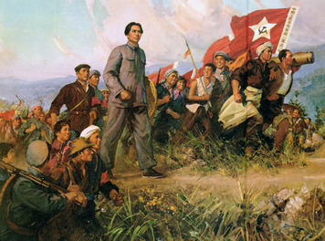
Mao Zedong hoped to lead Chinese peasants in a communist revolution. After Mao was expelled from the Nationalist Party in 1927, he organized a peasant revolt in Hunan Province. This Chinese propaganda poster shows Mao heroically leading his peasant army. Archives Charmet / The Bridgeman Art Library International
In 1928, Chiang captured Beijing and completed the Nationalists’ reunification of China. A new national government was established at Nanjing, with Chiang at its head. The West quickly recognized Chiang’s Nationalist government as China’s legal government.
The Rise of Mao Zedong One of the Communists who escaped to the countryside in 1927 was the head of the KMT’s propaganda corps, Mao Zedong. Like Chiang Kai-shek, Mao was the son of a prosperous farmer and merchant. Although he had no formal military training, he too took part in the 1911 revolution that overthrew the Qing dynasty. After the revolution, Mao drifted about, in search of education and a profession. May 1919 found him at Beijing University, where he took part in the May Fourth Movement.
Mao helped found the CCP in 1921 and was one of the first Communists to join the KMT, where he quickly rose to a leadership position. Along with other radical KMT leaders, Mao worked to organize peasants for a communist revolution. After being expelled from the KMT in 1927, he led a peasant revolt in Hunan Province. When Nationalist forces crushed the revolt, Mao and a few hundred survivors fled into the mountains. There he helped organize a Red Army of peasants and workers that by the spring of 1928 had some 10,000 troops.
The Communists’ Struggle for Power Mao wanted to wage a guerrilla war from bases in the Chinese countryside. The leaders of the CCP opposed this strategy. They ordered the Red Army to attack several major cities in south-central China in hopes of inspiring a workers’ revolution. No such revolution took place and the Communist forces were crushed by the Nationalist army.
The urban campaign’s failure increased Mao’s standing in the CCP. His followers created 15 rural bases in central China. From these areas, they seized land from wealthy landowners and gave it to the peasants. By 1931, the Red Army had grown to some 200,000 troops. Mao established the Chinese Soviet Republic in southeastern China, with himself as its head. Under his leadership, the Communists soon controlled a population of several million.
Chiang sent four expeditions to crush Mao’s government. The Red Army successfully fought them off using guerrilla warfare tactics. Finally, in late 1934, some 700,000 Nationalist troops advanced on the Communist capital. CCP leaders ordered the Red Army to directly attack this overwhelming force. The Red Army was nearly destroyed as a result. In October, Mao, other government and CCP officials, and the remains of their army broke through the Nationalist lines and fled.
Over the next 12 months they crossed 18 mountain ranges and 24 rivers in a 6,000-mile retreat that became known as the Long March. For the first three months, they suffered repeated attacks from Chiang’s ground troops and almost constant bombardment from his warplanes. Of the 100,000 Communists who began the Long March, only 8,000 survivors arrived at their new base in northwest China in October 1935. However, the retreat allowed Mao to oust his rivals and take control of the CCP.
With the Soviet border and Japanese-held territory in northeast China nearby, Mao was able to rebuild his army without fear of attack by Nationalist forces. By 1937, it again numbered about 100,000 troops.
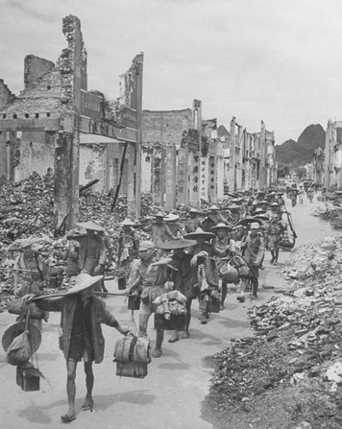
Thousands of Chinese died in World War II as Japan tried to destroy China’s will to fight in bombing campaigns. In this 1945 photo, Chinese civilians haul loads of rubble through a city destroyed by a Japanese attack. Jack Wilkes//Time Life Pictures/Getty Images
The Nationalists and Communists in World War II Japan’s invasion of China in 1937 brought a temporary halt to China’s civil war. Nationalist and Communist leaders agreed that it was better for both armies to resist the Japanese than to continue fighting each other. An uneasy alliance was formed. However, little cooperation existed. The burden of resisting the invasion fell on the Nationalist army. By the time Japan’s conquest was complete in 1939, Chiang’s army had been seriously weakened. It retreated into western China, along with other Chinese who fled from Japanese rule. This region became known as Free China.
For the rest of World War II, Japan tried to bomb Free China into surrender. Thousands of soldiers and civilians died. Free China was also plagued by political disputes and corruption. The Nationalist government and its army were further weakened as a result.
Meanwhile, the Communists broke most of the Red Army into small units. These groups went behind enemy lines to fight a guerrilla war against the Japanese. By the end of the war in August 1945, the Communists had gained control over thousands of miles and some 90 million people behind Japanese lines in northern and central China. The Red Army had grown to between 500,000 and 1 million troops.
Formation of the People's Republic of China With World War II over, conflict between China’s Communists and Nationalists resumed. The situation had changed, however. The war had left the Nationalists unpopular and weak, while the Communists emerged from it much stronger. A negotiated peace between the two groups was blocked by conservatives in the KMT, who still believed in a military victory. The fighting resumed in March 1946. The Nationalists made gains at first, but the tide soon turned in the Communists’ favor.
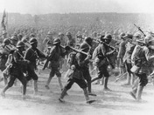
By 1945, the Red Army numbered between 500,000 and 1 million troops. In this photograph, Communist troops march on Shanghai in May 1949. The Communists took all major cities in China and drove the Nationalist army from the mainland. Keystone/Hulton Archive/Getty Images
Buoyed by widespread peasant support in the countryside and supplied with weapons left behind by the Japanese, the People’s Liberation Army (the Red Army’s new name after the war) began to push south in 1947. By late 1948, the Nationalist position was looking increasingly hopeless. In January 1949, the Communists took Beijing without a fight. Most of China’s other major cities soon passed from Nationalist to Communist control. Chiang Kai-shek abandoned mainland China, moving his government and remaining Nationalist forces to the nearby island of Formosa, which became the nation of Taiwan. He proclaimed the Taiwanese city of Taipei the temporary capital of China. On October 1, 1949, Mao Zedong announced the formation of the People’s Republic of China, with its capital at Beijing. The Nationalists remained in Taiwan.

Summary
In this lesson, you learned about events, conflicts, ideas, and other forces that brought great change to India and China.
Cultural Interaction Religious tensions between India’s Hindu majority and its Muslim population existed throughout the British Raj. As Hindus’ calls for independence from Britain grew, these tensions took on a political tone. The Muslim minority did not want to live under a Hindu-controlled government. So British divided India in 1947 to create two independent nations—a largely Hindu India and a largely Muslim Pakistan. Tensions increased in China when some Chinese tried to establish communism there. Other Chinese leaders opposed communism’s principles and practices. Differences between these groups led to war between them. The Communists won this war after a long struggle, and China became a communist nation.
Political Systems In the late 1800s, Indian nationalists began pushing for a greater Indian voice in India’s British colonial government. When Britain did not allow India self-government after its loyal support in World War I, a long period of unrest followed. Britain granted independence to India and Pakistan in 1947. In China, nationalists’ efforts to strengthen and modernize the nation brought revolution in 1911. China functioned as a republic for a brief time before political unrest divided the country. In the 1920s, attempts to reunite China resulted in civil war. The war ended in 1949, with China unified under Communist rule.
Human-Environment Interaction As Britain prepared to divide India in 1947, many Hindus lived in regions that were going to be part of Pakistan. Many Muslims lived in what would become the nation of India, where Hindus would be a majority. As independence approached, millions of India’s Muslims moved to Pakistan. Millions of Hindus relocated from Pakistan to areas that would remain part of India. Widespread violence between Hindus and Muslims encouraged this migration and accompanied it.

