Name: _______________________
Traveling Through Ancient Empires
You will be taking a journey around the world and examining three powerful ancient empires. During this journey, you will be stopping in four different countries including China, India, and Italy.
1. On the map below, find China, India, and Italy. Label each of these countries. Navigate through the following website if you need help locating the countries.
http://www.infoplease.com/atlas/

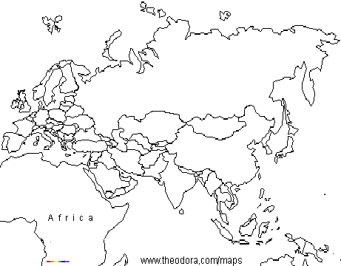
Gupta Empire
The first empire you will be exploring is the Gupta Empire. Click on the following to learn more information about the Gupta Empire before you travel there. http://regentsprep.org/Regents/global/themes/goldenages/gupta.cfm

1. What country is the home of the Gupta Empire? Color that country in BROWN on the map above. When did the Gupta Empire rule?
-

-

2. Why was the Gupta Empire successful?

3. What are three achievements that can be attributed to the Gupta Empire?

a.

b.

c.

4. What is the caste system?

5. Why did the Gupta Empire decline?

Gupta Culture
It is important to learn about a culture before you travel. Read over the following website and answer the questions about what life is like in the Gupta Empire. http://india.mrdonn.org/gupta.html

1. What were schools like? Would you like to attend school during this time? Why or why not?
-

-

-

2. What were villages like in the Gupta Empire? Is this similar to your city? Why or why not?
-

-

-

3. What were some of the important jobs that people did? What were some of the accomplishments during this period of time?

-

-

Han Dynasty
While the Gupta Empire proved to be very exciting, you will need to now travel to visit the Han Dynasty. Read over the following website and answer the questions about what life is like in the Han Dynasty. http://www.newworldencyclopedia.org/entry/Han_dynasty

1. What country is the home of the Han Dynasty? Color that country in RED on the map above. When did the Han Dynasty rule?
-

-

2. Why was the Han Dynasty successful? How were they able to stay in power?

-

-

3. What was the philosophy of the Han government?

4. What is the “Silk Road”? Why is it so important?
-

-

5. What lead to the fall of the Han dynasty?

Han Culture
It is important to learn about a culture before you travel. Read over the following website and answer the questions about what life is like under the Han Dynasty. http://china.mrdonn.org/han.html

1. What were schools like? Would you like to attend school during this time? Why or why not?
-

-

-

2. What were cities like in the Han Dynasty? Is this similar to your city? Why or why not?
-

-

-
3. What are three achievements attributed to the Han Dynasty?

a.

b.

c.

Roman Empire
While the Han Dynasty was also very exciting, you will need to now travel to visit the Roman Empire. Read over the following websites and answer the questions about what life is like during the Roman Empire.

- What country is the home of the Roman Empire? Color that country in BLUE on the map above. When did the Roman Empire rule? http://www.timemaps.com/civilization/Ancient-Rome

-

-

2. Why was the Roman Empire successful? How were they able to stay in power? http://www.crystalinks.com/romanempire.html

-

-

3. What was the government like in the Roman Empire? Focus on how it is similar to the government in the U.S. today. http://www.crystalinks.com/romelaw.html

-

-

4. What lead to the fall of the Roman Empire? http://webspace.ship.edu/cgboer/romanempire.html

Roman Empire Culture
Read of the following websites and answer the questions about life in the Roman Empire.

- What were schools like in the Roman Empire? Would you like to attend school during this time? Why or why not? Click on this link to find this information. http://www.historyforkids.org/learn/romans/people/school.htm

-

-

-

2. What were cities like in the Roman Empire? Is this similar to your city? Why or why not? http://www.crystalinks.com/romeculture.html

-

-

-

3. What are three achievements attributed to the Roman Empire? http://www.roman-empire.net/children/achieve.html

a.

b.

c.

