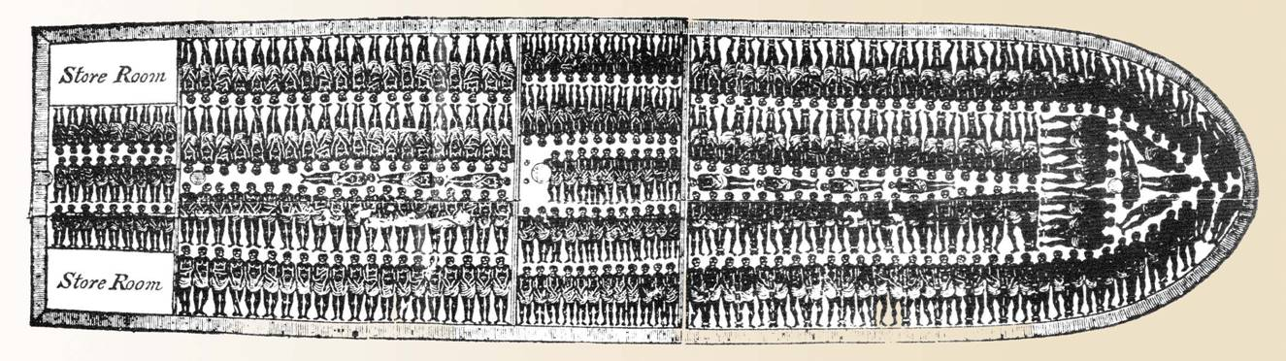

Expanding Empires and the Age of Exploration - Chapters 18, 19, and 20
Do not  understand  or have  never  heard of  this. | I  remember  something  but not  everything | I can  explain  this to  others | Pages  Section  in  the  textbook | Learning Targets
 |  |  | 19.1, 20.1, 20.4 | 5.1.1 – I can explain the impact of increased oceanic travel including changes in the global system of trade, migration and political power.
 |  |  | 19.1 | 5.2.1 – I can explain what led to European exploration.
 |  |  | 19.1, 20.1, 20.4 | I can describe the geographic routes used in the exchange of plants, animals, and pathogens among the continents in the late 15th century through the 16th century.
 |  |  | 19.1, 20.1, 20.2 20.3, 20.4 | I can explain the push/pull factors involved in the free and forced migration of people during the late 15th century through the 16th century, which impacted the natural environment, political institutions and societies.
 |  |  | 20.1, 20.3 | 5.2.2 – I can identify the causes and development of the Atlantic slave trade.
 |  |  | 18.1 | 5.3.1 – I can explain the impact of Ottoman rule during this time period.
 |  |  | 19.2 | 5.3.2 – I can explain reasons for the continuity of Chinese society under the Ming and Qing dynasties.
 |  |  | 19.3 | I can describe the changes in Japanese society brought on by the policies of the Tokugawa Shogunate.
 |  |  | 18.3 | 5.3.3 – I can explain the economic significance of India during the 15th and 16th centuries.
 |  |  | 18.3 | I can describe the role of foreign influence on the religious, political, cultural and economic transformations in the Mughal Empire.
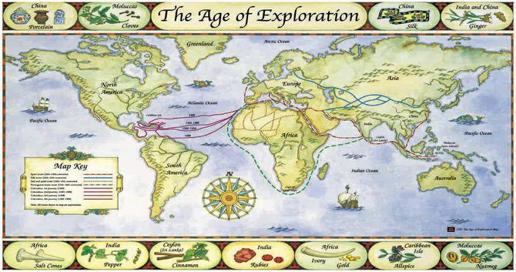

Expanding Empires and the Age of Exploration Identifications - Chapters 18, 19, and 20
Read the chapter sections and review your class notes on a daily basis in order to complete this test review. The test is _________________________.
For the test, be able to address the following:
- Know the political, economic, and social issues faced by Europe during the Age of Exploration.
- Know why the Chinese and Japanese begin a period of isolation from western influences.
- Know the role that the Ottoman and Mughal Empire played in international trade during the 15th and 16th centuries.
- Remember to check you “I Can” Statements. Be able to explain all of the “I Can” Statements.
HOW TO DO IDENTIFICATIONS FOR EACH UNIT
Identifications should be done in this manner:
TERM + identification phrase + interpretive commentary = 2 analytical (complex) sentences.
Term definition why it’s important
1. Migration: a permanent move from one place to another for which people move for social, political or economic reasons. The Bantus were forced to move south and southeast around Africa due to their farming techniques. (The first sentence is the definition from the book or power point lecture. The second sentence is from classroom activities or lessons that explains why the term is important/relates to other terms/relates to the section headings…) (worth 2 points each)
20.1 – 12/1/13 | 20.3 – 12/2/13 | 20.4 – 12/3/13
1. Colonies | 5. Atlantic slave trade | 8. Columbian Exchange
2. Conquistadors | 6. Triangular trade | 9. Capitalism
3. Mestizo | 7. Middle Passage | 10. Joint Stock Company
4. Encomienda |  | 11. Mercantilism
12. Favorable Balance of
Trade
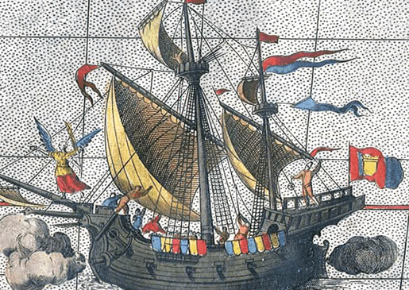 | 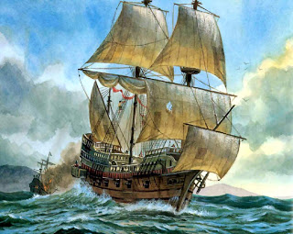 | Each identification is worth 2 pts each totaling 24 pts

