Section 1 — Introduction (all read)
About 50,000 years ago, according to a widely held theory, our earliest ancestors began migrating out of Africa. Over many thousands of years, descendants of those physically modern humans spread through Asia, Australia, and Europe. They replaced existing populations of more primitive human beings. Thus, the theory goes, all modern humans originated in Africa.
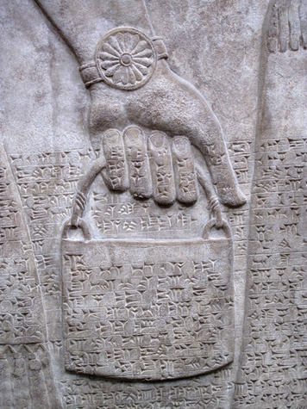
Not all scientists agree on the origins of the human race. But they would all agree with one statement. In nearly every environment that they encountered, early modern humans thrived.

Around 10,000 years ago, humans began settling down. They turned to agriculture, raising crops and animals for food and clothing. Populations grew. Some 5,000 years later, the first cities arose, and with them the first civilizations. In time, a few civilizations developed into powerful empires. At each step in this progression, peoples of ancient times had basic features in common. They followed leaders, engaged in economic activities, and developed social structures. These are a few of the features of civilization.
Through their accomplishments, these ancient peoples laid the foundations of world history. Theirs is the story of how human beings colonized the continents and went on to develop more and more sophisticated societies that interacted with one another in a multitude of ways. As you will learn in this lesson, their story begins with humans as hunter-gatherers.

Themes
Cultural Interaction The move from hunting and gathering to more complex societies resulted in an enormous increase in the exchange of cultural knowledge.
Political Structures Political structures became more complex throughout ancient times, moving from small family units to expansive empires.
Economic Structures Ancient economies developed from a reliance on hunting and gathering to a reliance on agriculture supplemented by trade and commerce.
Social Structures The human social structure shifted from the basic equality of hunting and gathering groups to the hierarchy of complex state societies.
Human-Environment Interaction Human impact on the environment intensified as societies shifted from hunting and gathering to agriculture.

Placard A - Hunter-Gatherer Societies
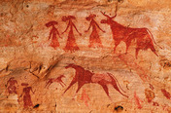
Prehistoric people left behind cave art that gives clues about how they lived. This cave art from the Ennedi Plateau in Chad, Africa, shows people and the animals they may have hunted. Ocean/Corbis

The earliest human beings appeared on Earth an estimated 2.5 million years ago. For nearly that entire time, humans lived as hunter-gatherers. They hunted wild animals and gathered edible plants. It was a simple existence. Early modern humans, who had populated much of the globe by 30,000 years ago, continued the hunting-and-gathering way of life. They lived at a time when the last Ice Age was ending. Earth’s climate was cycling through a series of warm and cold periods. Sea levels rose and fell. Across great areas of Earth’s surface, different forms of vegetation came and went. Humans survived by adapting to this changing environment. Like the environment, the humans, too, changed over time.
Self-Sufficiency During the Stone Age A few hunter-gatherer groups still exist today. They do not represent the great diversity of ancient hunting-and-gathering societies, but their way of life offers clues about early modern humans of the distant past. Those clues, along with evidence gathered by archaeologists, suggest that in a hunting-and-gathering economy the people were largely self-sufficient. They secured their own food supply and moved from place to place as needed to maintain it. They clothed themselves in the furs of animals that they had killed for food. They lived in caves, or they built shelters out of available materials, such as trees, brush, and animal hides. They crafted tools out of wood, bone, antlers, and stone.
Most of the materials used by ancient hunter-gatherers have disintegrated with the passage of time. The one that has survived the best is stone. When archaeologists dig at sites once inhabited by hunter-gatherers, nearly all of the tools and other artifacts that they find are made of stone. That explains the name given to the period between the emergence of stone tools and the later appearance of metal tools. Archaeologists call it the Stone Age. The Stone Age began some 2.5 million years ago. Archaeologists divide it into two major periods: the Paleolithic (“Old Stone”) and the Neolithic (“New Stone”).

Placard B – Hunter and Gatherer Societies
Stone Age Tools
Stone Age Tools When archaeologists find stone tools, they use them to gain insight into the group that produced them. By studying an ancient people’s tools, they can judge how advanced the community was. The earliest hunter-gatherers’ “toolkit” included stone flakes—sharp pieces of stone that could be used like knives to butcher animals. To produce them, people hit a large stone with a fist-sized stone in order to flake off pieces.
After a number of flakes had been removed, what was left of the original stone had a jagged edge. This stone tool might have served as a chopper, useful in cutting wood, cracking nuts, or breaking open bones for their marrow. It might have been used as a digger, useful for gathering edible roots. Both types of tool could also be used as weapons for hunting or for fighting.
Knowledge of how to make tools was culturally transmitted. That is, it was passed from one generation to the next. In this way it became part of the hunter-gatherer band’s culture—the shared beliefs, practices, and traditions of a group.
Through much of the Stone Age, tool-making techniques developed slowly. Archaeologists identify few differences in the design of tools made during that time. Near the end of the Paleolithic period, however, some dramatic changes took place. One advance was the development of composite tools, like the spear. It combined a sharp point with a wooden shaft, for thrusting or throwing. Other tools with a variety of specific uses began to appear. For the first time, hunter-gatherers began to use needles, often made of bone, to sew their clothing. Crude flakes were now worked into thinner blades and arrowheads.

Placard C – Hunter and Gatherer Societies
Quest for Food
The Quest for Food Hunter-gatherers relied for survival on the natural plant and animal resources found in their surroundings. They used their tools to gather, hunt, fish, and trap those resources. In the forested areas of Europe, for example, early modern humans gathered wild fruits, nuts, roots, and seeds. In meadows and on open plains, wild cereals grew along with wild peas, beans, and other plants. Game animals included rabbits, deer, and wild pigs.
To maintain a successful hunting-and-gathering economy, these early modern humans had to be mobile. That is, they had to be able to relocate often and quickly. Hunter-gatherers moved from one place to the next in an ongoing quest for food.
Much of their movement related to the seasonal migrations of the game animals that they hunted. They followed herds of deer and other animals as they moved from one grazing land to another. They trekked to coastal locations and rivers during the season when fish gathered there to produce and deposit eggs. They traveled to local lakes and marshes when it was time for migrating birds to stop there to feed. Gathering fruits, nuts, and other vegetative sources of food was also a seasonal affair. It, too, called for mobility.
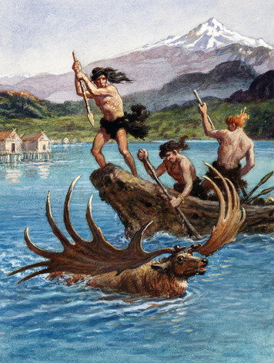 Increased Social Complexity At the end of the Paleolithic period, some hunter-gatherer communities were becoming more complex. They exhibited characteristics that set them apart from traditional hunting-and-gathering groups. Their populations were higher. Their base camps were larger and tended to become near-permanent settlements. They developed equipment for processing food and systems for storing and preserving it. Some hunter-gatherers may have sowed wild seeds to expand their source of plant food. The next step for these complex societies was to begin farming the land.
Mobility was a key to the hunting-and-gathering way of life. Nonetheless, later hunter-gatherers maintained “central places”—sites within their territory to which they continually returned. These base camps were usually located in a resource-rich area, perhaps along a seacoast or lakeshore or near known supplies of food or fuel. There they slept, made their tools, cooked their meals, and took part in social activities.

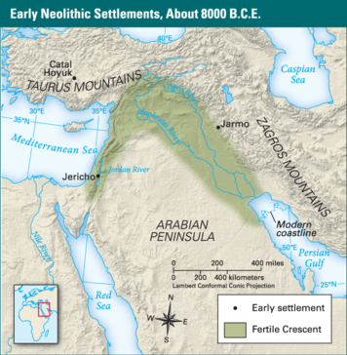
Hunting was a main source of food for early humans. Hunter-gatherers followed the herds of animals as they moved from place to place. Bridgeman
Having to be able to move with the seasons had its limitations. Hunter-gatherers could not afford to gather possessions. They had no pack animals to help them carry loads of belongings from one place to another. They had to carry everything themselves. For this reason, they took only a few tools, weapons, and other goods with them.

Early Neolithic Settlements, About 8000 B.C.E. Many Neolithic settlements were located in the Fertile Crescent, where the land was fertile. Here, people built towns such as Jericho, Catal Hoyuk, and Jarmo.
Complex hunter-gatherer societies appeared in regions that were rich in resources. Groups living in villages in such areas did not have to be particularly mobile. Nearly everything they needed for basic survival was available locally. One such region existed in Southwest Asia, in the area known as the Fertile Crescent. This arc of land extended from the eastern Mediterranean across southern Anatolia (Turkey) and south to the Persian Gulf. Here, some 8,000–10,000 years ago, the first farmers appeared.
Placard D – The Beginning of Agriculture -From Hunting and Gathering to Farming The western area of the Fertile Crescent, near the Mediterranean Sea, offered a wealth of natural resources. Small hunter-gatherer societies settled there. They hunted mainly gazelles but also smaller mammals and birds. They gathered fruits, tubers, and seeds—especially the seeds of wild grasses.
Farther east in the Fertile Crescent, in the foothills of the Zagros Mountains, other hunter-gatherers had a more mobile way of life. There, wild goats, sheep, and cattle migrated in the spring from the lowlands into the highlands, following the ripening pattern of the wild grasses. The hunter-gatherers moved with them, hunting the animals and gathering the seeds of the grasses.
Those grasses were the key ingredient in the momentous shift from hunting and gathering to farming. Farming involves both cultivating plants and raising animals. The first domesticated plants were grasses, in particular the large-grained cereals wheat and barley. The goats, sheep, and cattle that fed on wild grasses became the first domesticated animals (except for the dog, which had already been living with humans for thousands of years). Groups living in the Fertile Crescent also domesticated pigs.
Domestication is a biological process in which the physical characteristics of wild plants and animals change as a result of human intervention. The change likely happens over hundreds of years or more.
The following scenario suggests how hunter-gatherers might have begun domesticating wheat. Of two varieties of wild wheat, one dropped its ripened seeds when touched. That made it hard to harvest. Hunter-gatherers learned to collect only the variety that kept its seeds. That way, they could harvest the wheat by cutting the stalks and carrying them back to their village for processing. They saved and later sowed some of that same seed, intending to expand the resource in the wild. As a result, that one variety of seed began to dominate the local stands of wild wheat. Through this process, hunter-gatherers unintentionally changed the overall traits of the wheat in their territory.
In time, hunter-gatherers in the Fertile Crescent began to make these kinds of choices intentionally.
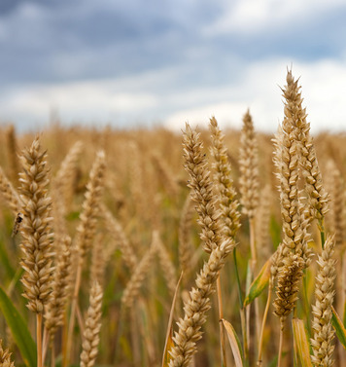
Wheat was domesticated in the Fertile Crescent region. This made the development of agriculture possible, which resulted in the beginning of settled society.

• They selected plants, as well as animals, that had favorable characteristics. • By around 9,000 years ago, they were cultivating wheat— preparing the ground and then sowing and harvesting the seeds. They also grew barley, lentils, chickpeas, peas, and beans. • They built structures for storing their food. • Near their fields, they built houses, which together formed a farm village. • They may have continued to hunt or to gather, but eventually, most came to rely on their domesticated plants and animals to provide for their basic needs. • They were sedentary—they stayed in one place, in permanent, year-round settlements. • They had become farmers.
Later, some groups moved away from the centers of farming to take up a herding way of life. On the grasslands of the Fertile Crescent, they lived with their herds of domesticated sheep, goats, and cattle. Periodically, they moved with the herds as the animals moved to fresh pastures. People who establish this kind of food-producing economy are called pastoral nomads. The nomadic herders of the Fertile Crescent likely preferred life in the wide-open spaces to life in the farm villages.
Placard E – The Beginning of Agriculture
Why Agriculture Arose
Increased knowledge of how to domesticate plants and animals is just one reason scholars give for why agriculture began when it did. They also note the development of new technology for gathering, processing, and storing foods. Another important factor is climate. The last Ice Age ended around 11,500 years ago. After that time, Earth’s climate remained generally stable. In the Fertile Crescent and other places in which farming began, the climate turned favorably warm and rainy. Yet another reason for the rise of agriculture was population pressures. As populations increased, hunter-gatherers needed to expand their supply of food. Farming met this need.
The Spread of Agriculture In 10,000 B.C.E., nearly every human was a hunter-gatherer. By 1 C.E., most were either farmers or herders. The shift from hunting and gathering to agriculture, once it had started in any location, took hundreds or thousands of years. During the transition, groups acquired needed resources through a mix of hunting, gathering, farming, and herding.
Agriculture was independently invented in China 8,000 years ago with the domestication of rice and millet. This photo shows terraced rice fields in modern-day China.

Placard F – Cultural Diffusion
Agriculture first appeared in the Fertile Crescent around 9,000 years ago. Through cultural diffusion, it spread from there to Egypt, Europe, and India. Knowledge of agriculture might have been carried to those places by pastoral nomads, some of whom were also skilled farmers. These mobile peoples were free to travel far from their home territory, wherever there was grass to feed their herds. Another way that agriculture spread was through the migration of farming peoples.
By 8,000 years ago, rice and millet were being domesticated in China. By 5,500 years ago, maize (corn) was being domesticated in the Americas, followed about a thousand years later by llamas. Agriculture appears to have arisen independently in these two places, as well as in sub-Saharan Africa and elsewhere.
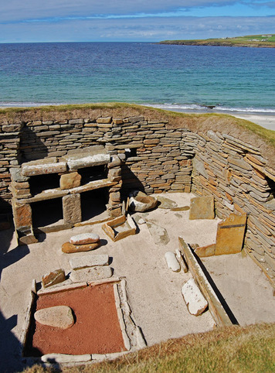
The ruins of the Neolithic village of Skara Brae are located on the coast of Scotland. The village consisted of ten round houses that were sunk into the ground as protection from harsh winter weather. Inventions of the Neolithic period such as pottery and improved stone tools have been found at Skara Brae. These new technologies made settled life possible.

Cut and read together: The Impact of the Shift to Agriculture The shift to agriculture ushered in the Neolithic period, or New Stone Age. Neolithic peoples developed new technologies to feed the ever-growing population. They crafted better stone tools, such as the stone-bladed plow for tilling the soil. They created pottery for storing food and decorated it with distinctive styles. In time, they invented the wheel, which served as a turntable for pottery-making and was a landmark improvement in transportation.
The expansion of agriculture changed people’s relationship to the environment. Instead of drawing resources from an extensive territory, as hunter-gatherers did, farmers cultivated a small area intensively. In wooded regions, farmers cleared the ground through slash-and-burn methods. They chopped down trees and set fire to any remaining vegetation.
The rise of agriculture also had an important social impact. The population density—the number of people in a unit of area—rose as kin groups came together in farm villages. Humans, now sedentary, began to accumulate goods, sometimes in exchange for surplus crops. These included not just practical goods such as pots and grinding stones but also beads and bracelets made of imported shells and precious stones. Ownership of such luxury goods brought respect and signaled a family’s wealth, as did the amount of land it farmed or the size of its herd.
Wealth gave individuals power. It set them apart from others. Instead of the equality that characterized hunter-gatherer societies, farming villages gradually became stratified. People were divided into status groups based largely on wealth.
The shift from hunting and gathering to agriculture is often called the Agricultural Revolution. Some scholars refer to it as the Neolithic Revolution to suggest that its impact went beyond farming. Whatever the name, this shift was, indeed, revolutionary. In the past, advances in human knowledge tended to remain within each isolated hunter-gatherer culture. Now technological and social innovations could be passed easily not only from one generation to the next but from one culture to another.

Placard G — The Rise of Civilizations
Settlements that arose during the Neolithic period grew in population and social complexity. Villages became towns. Over time, towns became cities. In a few of the world’s river valleys, humans took the next step. Actually, they took an enormous jump. They developed the first civilizations.
Characteristics of a Civilization A civilization is a highly organized and complex society. This definition, however, is a bit too tame for historian Michael Cook. He declares that “the term civilization suggests that there is in fact some kind of quantum leap in complexity.”
One “quantum leap” involved the development of writing. Before the rise of the first civilization, writing did not exist. The names of people, places, and events were not recorded. Humans had the necessary tools—sticks and brushes, inks and paints. But they needed something much more abstract. To acquire writing, a society had to find a way to represent spoken language with visual symbols. Each of the world’s earliest civilizations managed to do this.
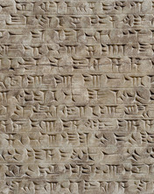
The invention of written language was one of the “quantum leaps” made by the first civilizations. This photograph depicts cuneiform, the wedge-shaped writing developed by the Sumerians.
Ancient civilizations commonly shared several other characteristics besides writing. One was geography. Ancient civilizations arose in river valleys, where access to water and fertile soil made farming much more productive.
Another characteristic of ancient civilizations was large cities. Unlike agricultural villages, populated by related families, cities drew a wide mix of peoples from the surrounding region. Usually, the urban social system evolved into a hierarchy—a ranking of groups of people according to their importance, status, or power. One person, the king (or priest-king), held the top rank.
Most cities contained large public structures—palaces for kings and temples for priests—as well as markets for the exchange of goods. Rulers typically managed the economy, supporting state activities by taxing farmers, merchants, and artisans or by forcing people to labor for the state.

Placard H – Rise of Civilizations
Why Civilizations Emerged

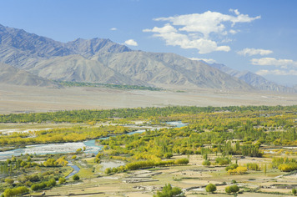
The first civilizations rose in fertile river valleys. Shown here is the Indus River valley in present-day India.
Why Civilizations Arose Each of the major early civilizations developed in a unique way. Scholars have found no single cause that explains why they arose. Instead, they cite a number of factors that worked together to bring about civilizations.
• Access to Water Complex states formed, in part, as a result of the success of agriculture. Irrigation played a key role in that success. The first civilizations developed in fertile river valleys, where farmers built canals and other structures to carry river water to their fields or to store floodwater. Ready access to water greatly improved crop yields—the amount of food that could be grown per acre. Plentiful food led to expanding populations. Settlements eventually became cities.
• Government As a settlement’s population increased, its society changed in a number of ways. One way related to government. Some societies replaced rule by elders with rule by a central authority, the state. The state, run by the king and a multitude of trained officials, was better able to organize and coordinate the activities of the increasingly more complex society.

Placard I – Rise of Civilizations
Why Civilizations Emerged continued
• Defense Growing communities competed with one another for resources. Competition could lead to conflict. For defensive purposes, large settlements built walls around themselves to ward off invaders. Kings sometimes gained power through their success in battle. But they took responsibility for the society’s prosperity as well as its defense.
• Specialized Jobs With advances in agriculture, farmers were able to grow more than the society could consume, which meant that everyone did not have to be a farmer. Food surpluses supported those who chose to specialize, full-time, in other areas. They became artisans and warriors as well as priests and government officials.
• Trade Some became merchants, or traders. Growing settlements found that they could not produce all the resources that people needed or wanted. They engaged in long-distance trade both for necessities, such as raw materials, and for luxury goods. Having a steady supply of goods helped settlements grow, and thus trade was yet another factor in the rise of civilizations.

Placard J - River Valley Civilizations
The earliest civilizations formed in river valleys, where rich soils encouraged high agricultural yields. That productivity, and the resulting surpluses, played an important role in the development of complex societies. Some 5,000 years after farmers first cultivated the soil of the Fertile Crescent, the region gave birth to the world’s first civilization in Mesopotamia. From there, trade contacts may have spread the concept of civilization to Egypt and the Indus River Valley. As with agriculture, China appears to have developed its first river valley civilization independently.
Mesopotamian Civilization Around 3500 B.C.E., the world’s first civilization arose in Mesopotamia. This region was located in the eastern part of the Fertile Crescent. Through this region flow two rivers, the Tigris and the Euphrates. Mesopotamia means “the land between the rivers.”
Some 2,000 years earlier, farmers from the foothills of the Zagros Mountains began moving into the river valley. Little rain fell in the valley, but its soils were fertile. By diverting river water through canals to their fields, the farmers found that they could grow far more crops than they had been able to in the hills. Those crops included wheat, barley, and date palms. Use of the plow, animal power, and wheeled carts added to their success.
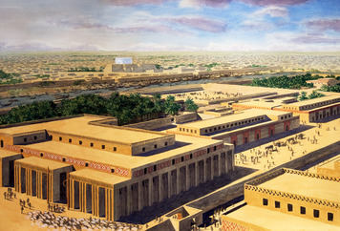
Sumerian cities centered around temples. This is an artist’s interpretation of what the temple in the Sumerian city of Uruk may have looked like around 3000 B.C.E.
By 3000 B.C.E., several city-states had appeared in southern Mesopotamia in a region known as Sumer. These independent urban centers dominated the surrounding farmland and pasturelands.

Sumer’s cities had formed around temples. The temple became the central agency that ran the city’s affairs. Priest-kings and their officials managed the economy. The grain that farmers produced went into temple storehouses, from which it was redistributed to the people. The temple kept a portion of the crops to finance the building and maintenance of canals, temples, and city walls. Surplus crops also paid for weapons. The city-states of Sumer regularly fought one another over land and water.
The Sumerians invented a writing system known as cuneiform. Its picture-symbols were pressed into soft clay tablets using a tool that made a wedge-shaped mark. Cuneiform means “wedge-shaped.” Sumerian officials first used cuneiform as a way to keep track of grain, animals, tools, workers, and much more. Later tablets recorded land sales, poetry, and descriptions of battlefield victories. Even after Sumer itself faded away, cuneiform continued to spread throughout Mesopotamia, as did Sumerian culture.
Southern Mesopotamians produced lots of clay, grain, and wool but not much else. They traded with other parts of the Fertile Crescent region for hardwood, stone, copper, gold, and semi-precious stones. They also engaged in interregional exchange to acquire luxury goods from places as distant as western Anatolia and the Indus River Valley. The main principles of civilization may have traveled along these and other trade routes, likely reaching Egypt in the mid-to-late 3000s B.C.E.

Placard K – River Valley Civilizations
Egyptian Civilization Egypt, a desert country, has been called “the gift of the Nile.” The Nile River flows south to north, arising in the highlands of eastern Africa and emptying into the Mediterranean Sea. In Neolithic times and beyond, the Nile overflowed its banks each summer. The floodwaters deposited fertile silt onto the adjoining lands.
Sometime after 5000 B.C.E, agriculture appeared in the Nile Valley, imported from the Fertile Crescent. Egyptian farmers grew the cereal grains barley and wheat, as well as flax, a plant whose fibers they wove into linen. They irrigated their crops from natural basins that retained some of the annual floodwaters. Farmers also raised cattle, goats, sheep, and pigs.
Increased production of food led to dramatic gains in population. By the late 3000s B.C.E., some farm villages had expanded into cities. Egyptian cities, unlike those in Sumer, did not become independent states, each with its own king. The main cities formed in the delta region, known as Lower Egypt, where the Nile split into branches that each emptied into the sea.
In the rest of this ancient land, known as Upper Egypt, several large bands of people competed for power. Around 3100 B.C.E., a leader named Menes took control of Upper Egypt and then conquered Lower Egypt, uniting the country for the first time. King Menes thus launched Egypt’s first dynasty. A dynasty is a series of rulers who come from the same family.
By the time of Menes, priests had developed their own writing system, called hieroglyphics. Hieroglyph means “sacred carving.” Scribes, specialists in the art of writing, used hieroglyphics to keep records and to communicate information. They carved the hieroglyphs on the stone walls of temples and tombs as well as on metal, wood, and clay. But they also wrote them with brush and ink on a paper-like material called papyrus, made from reeds.
Later Egyptian kings were commonly called pharaohs. The pharaoh was an absolute monarch—a ruler whose power is unlimited. By tradition, the pharaoh owned all of Egypt’s land. As a result, through his palace officials—many of whom were scribes—he managed the economy as well as the government.
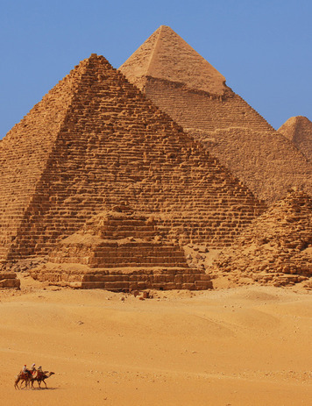
These massive stone pyramids were constructed at Giza in Egypt in the mid-2000s B.C.E. They were built using forced labor under the direction of the pharaohs, who were absolute monarchs. Danbreckwo... | Dreamstime.com
Farmers paid part of their crops as taxes to officials. That surplus grain was then redistributed to non-farmers, with a portion reserved to pay for public-works projects. The government could also levy taxes in the form of forced labor in order to carry out those projects. For example, it recruited villagers and artisans to help build the massive stone pyramids of Giza in the mid-2000s B.C.E.

Placard L1 - Indus River Valley Civilization Sometime after 3000 B.C.E., in what is now Pakistan, a new civilization developed in and near the valley of the Indus River. The river arose in the high mountains of the Himalayas and flowed south through semiarid plains to the Arabian Sea, a part of the Indian Ocean. When it flooded each summer, the river deposited a layer of fertile silt that made for easy tilling of the soil.
That soil attracted farmers, who built villages and, in time, cities. The Indus River’s floodplain extended far from the river. Because of extensive floodplain, the Indus Valley civilization spread over a larger area than that of Mesopotamia or Egypt.
The Indus often flooded deeply, so farmers built their settlements on high ground and surrounded them with barriers of stone or earth. They planted wheat and barley when the floodwaters receded. At some point they also began growing cotton. Some historians think that in the dry season they kept their crops watered through a network of irrigation canals. Farmers also domesticated cattle and other animals, likely including elephants.
The Indus Valley culture developed a writing system, but scholars have had little success decoding it. For this reason, they know much less about the ancient Indus River region than they do about Mesopotamia or Egypt. Their descriptions of the civilization are based largely on their studies of the ruins of Indus Valley cities and other settlements.
The studies reveal that the Indus Valley civilization was home to around 100 villages and several walled cities. Two large cities, Harappa and Mohenjo-daro, dominated the region.
Harappa and Mohenjo-daro reflected the organization and complexity that is a key sign of a civilization. Each consisted of two sections—an elevated citadel, or fortress, and a lower residential area. Both were surrounded by walls. In the citadel, members of the ruling class likely conducted their political business and carried out religious rituals. In the residential city below, the people lived in brick houses linked by an orderly arrangement of streets. The finer homes had wells for water and bathrooms that drained into the city’s main sewer system.
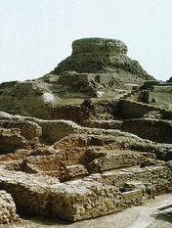
The ruins of Mohenjo-daro, one of the largest cities of the Indus Valley civilization. The elevated structure in the center was the citadel, and the lower buildings around it were residential areas. The Art Archive
Within the lower city lived shopkeepers, merchants, scribes, and artisans. The artisans manufactured a variety of goods, including metal ornaments and weapons, fine ceramics, and cotton cloth. Woven cotton textiles and beads of semi-precious stone both served as popular goods for export. Indus Valley trade goods flowed northwest over the mountains to Iran and later also by boat across the Arabian Sea and through the Persian Gulf to Mesopotamia.
Placard L2 - Chinese River Civilizations Two major river systems dominate China. Both flow generally west to east but in a weaving pattern that follows the contours of the landscape. The Huang He (huang heh), or Yellow River, is in the north. The Chang Jiang (chahng jyahng), or Yangtze River, is in the south. Chinese civilization arose in the valleys of both of these rivers at about the same time.
Early farmers were attracted to the fertile yellow soil, known as loess (less), that blankets the broad plain of the Yellow River. Yellow silt clouds the river, giving it its name. Farmers in the valley grew millet, a cereal grain, using dry farming rather than irrigation. To make up for lack of rain, they planted drought-resistant millet and learned ways to conserve soil moisture.
The agricultural settlements that appeared in the valley grew in population and complexity. By around 2000 B.C.E., several of them reflected key characteristics of civilization. Within large centers surrounded by defensive walls, artisans specialized in the making of ceramic pottery and the carving of jade, a semiprecious stone. They also worked copper and, later, bronze. Societies evolved a hierarchy, with a privileged minority at the top whose members could afford luxury goods obtained through long-distance trade.
The Shang (shahng) Dynasty came to power in the Yellow River Valley around 1600 B.C.E. The Shang may simply be one of several early Chinese civilizations. But it is China’s first historical state. That is, the Shang were the first to record their dynasty’s history using a formal writing system.
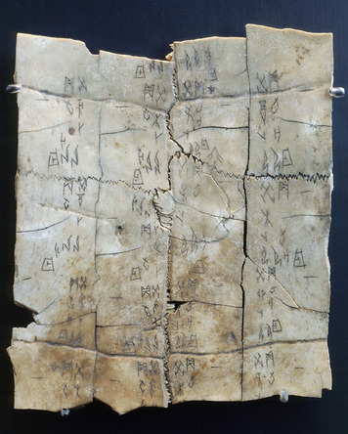
This tortoise shell oracle bone dates from the Shang dynasty in China. The writing on surviving oracle bones is an important source historians have about ancient China.
Their writing, or script, consisted of pictograms that stood for objects and ideas. That script appeared on bronze vessels, silk, and strips of bamboo linked with thread. It also appeared on what were called oracle bones. These cattle bones and tortoise shells served a special purpose. Shang diviners—persons who use magic to predict the future—first posed a question and then applied heat to the bones, causing cracks to form. The diviner then interpreted the cracks, with the goal of predicting the future.

A typical question concerned the health of the king or the success of warfare, hunting, or crops. On each oracle bone, they wrote the date and the question and, sometimes, the interpretation. Thus oracle bones comprise an important source of historical information about ancient China.
Civilization arose in a similar way to the south, in the Yangtze River Valley. Walled cities with hierarchical societies developed within an agricultural setting. However, farmers in this warmer and wetter region of China cultivated rice rather than millet, and they diverted water from the rivers as needed to irrigate their crops.
Chinese scholars refer to the several complex states that formed along the Yangtze as the Changjiang civilization. A key city in this civilization was Sanxingdui. In workshops outside the massive walls of this city, artisans crafted a variety of objects from clay, jade, ivory, turquoise, and bronze. The bronzes are particularly impressive. One, a statue of a man wearing a crown, stands more than 8 feet tall. Another, a sculpted tree with leaves, buds, and fruit—and a bird perched on each branch—rises 13 feet into the air.

Placard M - Ancient Empires
Ancient history is full of empires. In an empire, a single ruler governs a number of different lands or peoples.
The Parthenon, a temple dedicated to the goddess Athena, was built in the Greek city-state of Athens between 447 and 438 B.C.E. It still stands today and has become a symbol of ancient Athenian democracy.
Ancient empires typically developed when a powerful state conquered its weaker neighbors. Around 2350 B.C.E. in Mesopotamia, Sargon of Akkad formed the world’s first empire. The Roman Empire, however, is likely the most famous ancient empire. Rome and another, earlier Mediterranean state, the Athenian Empire, experienced what is known as a classical age. The government, arts, and ideas generated by those civilizations had a lasting impact on world history and culture. Other classical ages occurred in China under the Han dynasty and in India under the Mauryan and Gupta dynasties.

The Athenian Empire Greece is a mountainous peninsula that juts southeast from the European continent into the Mediterranean Sea. In ancient times, many city-states arose on the Greek mainland and islands.
The Greeks called themselves Hellenes. They had the same ethnic background, shared the same customs, and spoke the same basic language. However, their city-states preferred to remain independent. Nevertheless, they came together politically when threatened by an outside power—or when forced to by a dominant city-state.
One such city-state was Athens. There, in 508 B.C.E, the world’s first democracy appeared. The Athenians cherished their liberty, both personal and political, and they designed a government that would protect it. Theirs was a direct democracy—citizens participated directly in the rule of their state. Women, foreigners, and slaves were excluded from citizenship. Everyone else over age 20 had a right to vote in the people’s assembly and to make speeches there concerning public policy. They could also elect magistrates, the officials who carried out decisions made in the assembly.
Pericles, a general and a leader of the Athenian democracy, offered this insight into his city-state’s government:
Our constitution does not copy the laws of neighboring states; we are rather a pattern to others than imitators ourselves. Its administration favors the many instead of the few; this is why it is called a democracy. If we look to the laws, they afford equal justice to all . . . .
—Pericles, “Funeral Oration,” 430 B.C.E.
Warfare threatened Athens, and its democratic freedoms, throughout the classical age. In 490 B.C.E., the Persian Empire of Southwest Asia invaded Greece, but the Athenian army fought them off. Ten years later the Persians sailed across the Aegean Sea and attacked once more. They were again defeated, this time by a group of city-states led by Athens and long-time rival Sparta. The Athenian navy, which ruled the seas around Greece, played a key role in the victory.
In 478 B.C.E., Athens formed an alliance with a number of island and coastal city-states around the Aegean Sea. Their goal was to defend against further Persian invasions and to attack Persian strongholds in the region. Athens, with its powerful navy, took charge. It decided which states would provide ships or money to support what historians call the Delian League.
Eventually, the Delian League had some 200 members, with Athens in firm control. By the 440s B.C.E., the contributions of most city-states took the form of tribute—payment made as a sign of submission—sent to Athens’s treasury. What had started as an alliance had become an Athenian Empire.
Athens continued to expand its empire. In response, Sparta put together its own alliance of Greek city-states. In 431 B.C.E., Sparta attacked Athens. Thus began the Peloponnesian War. By the time it ended in 404, the Athenian navy had been smashed and Sparta had taken command in Greece.
In the following century, Athens made a strong recovery and even restored its empire. But the end of its power came in 338, when an army from the kingdom of Macedonia, a northern neighbor, conquered all of Greece. The Greek culture did not disappear, however. A Macedonian king, Alexander the Great, overran the Persian Empire, capturing lands stretching from Egypt east to India. He founded new cities in those lands. Greek and Macedonian settlers in those cities spread Hellenism—Greek language, customs, and philosophy—through much of Alexander’s empire.
Placard N – Ancient Empires: The Roman Empire
At its largest, the Roman Empire extended over the entire Mediterranean region and large parts of the Middle East and Europe.
The Roman Empire Greek city-states continued to function until, in the 100s B.C.E., they were crushed by a new Mediterranean powerhouse. The Rome Empire began as a city-state in the middle of the Italian peninsula. It grew steadily through military aggression, and it would keep expanding for about 400 years. Rome’s conquest of the Mediterranean region made it an empire, although the Romans still thought of their country as a republic. A republic is a system of government in which the people rule through representatives.

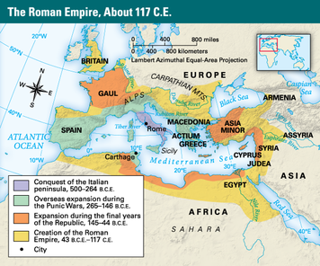
Romans had founded the republic after dethroning their king in 509 B.C.E. They resolved to govern the Roman Republic according to laws. Around 450 B.C.E., to ensure the rights of all citizens in the courts, the Romans compiled their first set of written laws, the Twelve Tables.
Rome’s republican system had three main parts—popular assemblies, magistrates, and the Senate. In assemblies, male citizens voted on laws and elected magistrates to carry out the laws. The magistrates at first selected the members of the Senate, who wrote legislation and handled foreign affairs.
Later the Senate, grown much more powerful, severed its link with the magistrates and assemblies. However, in later years the Senate surrendered much of its authority to the emperor.
For much of the late Republican period, Rome was an empire. The military deeply influenced Roman society. All citizens were expected to serve as soldiers. The state’s leaders came largely from the military. Rome’s main foreign policy was to expand its borders through conquest.
Rome was continually at war. Major conflicts included the three Punic Wars, which started in 264 B.C.E. and ended in 146 B.C.E. with the complete destruction of the North African city-state of Carthage. This was followed by wars of expansion in Anatolia, Syria, Gaul (France), and Britain, by battles along the frontier with Germanic peoples, and by several slave revolts and civil wars. One civil war ended when a rebellious Julius Caesar defeated Pompey the Great. Caesar then made himself sole ruler of Rome. After Caesar’s assassination in 44 B.C.E., his great-nephew Octavian stepped into the power vacuum.
This is a statue of Octavian. He became the first official Roman emperor in 27 B.C.E. and assumed the title of Augustus (“majestic”). He is depicted here with idealized features in a style influenced by Greek sculpture.

In 27 B.C.E., Octavian became the first official emperor. He assumed the title Augustus, which means “majestic.” Under Augustus and the next 15 or so emperors, the Mediterranean region enjoyed a time of relative calm known as the “Pax Romana,” or “Roman Peace.” The Romans, great road builders, extended their network of roads into conquered territories. This made the movement of troops to Roman colonies easier. It also encouraged trade and the diffusion of Roman culture and ideas throughout the empire. Rome also extended citizenship rights to conquered peoples, which helped integrate them into Roman society and government.

Tranquil times ended in the late 100s C.E., when the empire was battered by periods of civil war and military rebellion. A series of short-lived emperors added to the instability. In the late 200s, Emperor Diocletian split the empire into eastern and western halves. The “Roman Peace” was shattered for good in the 300s, when migrating Germanic peoples crossed the frontier and began to take over Roman lands. In 476, these peoples brought the Western Roman Empire to an end.
Placard O - The Han Dynasty The Han came to power in 206 B.C.E., after a civil war toppled the Qin (chin) dynasty. Just 15 years earlier the Qin had united all of China under a single emperor. The Han ruled for two centuries, lost control from 9 until about 25 C.E., and then ruled for another two centuries. During the earlier period of rule, called the Western Han, the capital was at Chang’an (chahn-ahn). The later period is called the Eastern Han, when the capital was moved eastward to Luoyang (lwaw-yahng), on the Yellow River.
The Qin had unified China after a long period of warfare among rival states. One goal of the Han government was to keep China stable. To do this, the Han needed loyal and capable officials to administer the government, especially in the outlying provinces. The Han established centers for the training of scholar-officials based on the teachings of Confucius, a philosopher born in the mid-500s B.C.E. Those teachings emphasized proper behavior and the maintenance of traditional ways and values.
Another goal was to enlarge the empire. The Han army, equipped with the newly invented crossbow, gained new territory in several directions. To the north they pushed the fearsome Xiongnu (SHE-OONG-noo) people, also known as the Huns, away from the Great Wall that hugged China’s border. To the northeast the Han colonized part of the Korean peninsula. To the south they took possession of coastal lands well into Vietnam. To the west they gained control of caravan routes that passed through Central Asia.
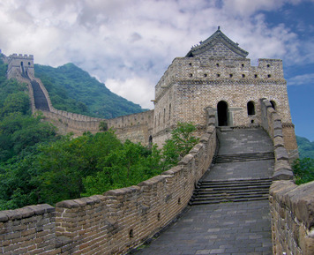
The Han army drove the fearsome Huns away from their border with the help of the Great Wall and the newly-invented crossbow. The Han dynasty brought around 400 years of security and progress to China. Jf123 | Dreamstime.com
As a result of the westward expansion, the Han opened up interregional trade starting around 100 B.C.E. They exported mainly silk, some of which reached as far west as Rome. The trade routes across Asia became known as the Silk Road. The Silk Road also carried goods and ideas eastward into China, including Buddhism, a religion that arrived from India during the time of the Eastern Han dynasty.
During the Han period, China’s population grew. The government sought to increase food production by encouraging farmers to move out of the densely populated Yellow River Valley. To help them resettle in northern border lands, the Han provided farmers with land and houses. Other farmers migrated south to take up rice farming in the less-populated Yangtze River Valley, where the government built irrigation works. Advances in iron-making also boosted agriculture. Farmers could till the soil more effectively using iron rather than wood or stone blades on their plows.
The Han dynasty brought China some 400 years of security and progress. Han China nearly matched the Roman Empire in size. Under the Han, the Confucian ideal took hold and became a permanent anchor for Chinese society. Today, when the Chinese refer to traditional Chinese culture, they mean the way of life that developed under the Han dynasty.
The Mauryan Empire and Gupta Empire Historians have long described the era of the Gupta (GOOP-tuh) Empire (320–535 C.E.) as India’s classical age. But many also see the earlier Mauryan (MOOR-yuhn) Empire (321–185 B.C.E.) as a key period in India’s history. Leaders of both empires united much of South Asia from their homeland in the Ganges River Valley of northern India.
The most admired leader of the Mauryan Empire was its third king, Ashoka (uh-SHOKE-uh). Ashoka set out to expand the empire, but a massacre stopped him. The slaughter, by his troops, of many thousands of people from the east coast kingdom of Kalinga had a profound effect on Ashoka. He converted to Buddhism, a religion of peace, and vowed to conquer not through military force but through the moral teachings of dharma (DAHR-muh).
This is an example of a pillar erected by Ashoka, the third king of the Mauryan Empire. Ashoka’s pillars were inscribed with his edicts, which expressed his Buddhist philosophy.

Ashoka sent Buddhist missionaries throughout the empire and also into Southeast Asia and Central Asia. He instituted religious tolerance in India, supporting Buddhist as well as non-Buddhist groups. Ashoka also issued edicts expressing his philosophy. These decrees were carved into stone pillars. Through these and other actions and policies, Asoka worked to unify the many different peoples of his empire.
After Ashoka’s reign, the Mauryan Empire gradually fell apart. The rulers of the next great Indian state, the Gupta Empire, maintained Ashoka’s policy of religious tolerance. They did not, however, follow Ashoka’s lead when it came to conquest. They relied on military force to gain territory. The Gupta army, made up of horse-mounted archers, an elephant corps, and foot soldiers, had great success in battle.
Agriculture and interregional trade also helped the Guptas build an empire that enjoyed peace and prosperity. The state appears to have assisted farmers by providing irrigation works, although it did take part of the farmers’ crops as taxes. By this time, the secret of growing silk had reached India from China, and silk weaving was flourishing. As the Western Roman Empire declined, Gupta traders sold costly silk cloth to the Eastern Roman, or Byzantine, Empire. They also increased trade with Southeast Asia.
Gupta emperors spent some of their wealth in support of the arts and sciences. At least one emperor maintained several scholars at his court. Religious art was widespread. Images of the Buddha appeared in various formats, including copper sculpture and colorful painted murals. Religious literature also enjoyed popularity, as did a variety of non-religious drama and poetry. Gupta mathematicians in the 400s were aware of the concept of zero and employed the decimal system. By the end of that century, Indian astronomers had calculated pi and had determined that Earth rotates on its axis and revolves around the Sun.

Summary – Read together
In this lesson, you learned about the development of hunting and gathering societies, the beginnings of agriculture, and the rise of ancient civilizations.
Cultural Interaction Most cultural knowledge accumulated by hunter-gatherers stayed within the group. Farmers and herders had more interaction with outsiders. Knowledge of agriculture appeared first in the Fertile Crescent and spread from there to Egypt, Europe, and the Indus River Valley. The main principles of civilization spread in a similar way, although civilizations also arose in several places independently. Complex societies exchanged elements of their cultures, often along trade routes. In this way Buddhism spread from India to China.
Political Structures Political structures grew progressively more complex during ancient times. Elders served as leaders of hunter-gatherer groups and farm villages. Civilizations often turned to priest-kings for leadership and a set of officials to carry out government policy. Strong states arose, and some, through conquest of neighboring lands, became empires.
Economic Structures The earliest humans survived by hunting animals and gathering plants. The development of agriculture, marked by the domestication of food plants and animals, led to an increase in the production of food. Surplus crops allowed some members of society to pursue non-farming activities, including trade. Agriculture remained the basis for the economies of even the largest states and empires. Trade brought them needed goods as well as luxury items.
Social Structures Hunter-gatherer and ancient village societies were made up of kin groups, or related families, in which all members had fairly equal status. Generally, the men did the hunting and the women did the gathering. Cities drew their much larger populations from a variety of different groups within the surrounding region. In such complex states, societies evolved hierarchies, often based on differences in economic status.
Human-Environment Interaction Mobility was a key characteristic of hunter-gatherers. They moved from place to place to maintain access to the animals and plants that gave them food, clothing, and shelter. Farmers stayed in one place and tended to settle in resource-rich areas. They cleared land near their villages for planting crops. The first civilizations rose in river valleys, where fertile soils and irrigation water helped them raise plenty of food. Improved tools, such as the plow, also boosted food production.
Material that was cut:
Interactions Within and Between Groups Hunter-gatherer bands consisted mainly of kin groups—people who claim a common ancestor. Bands typically ranged in size from 30 to 50 people. They shared food and otherwise worked together for common ends. Their economy was based on a division of labor. Men did the hunting and women did the gathering. Nonetheless, members of hunter-gatherer bands generally enjoyed equal status in the group. They had no real government—no one person had political power. But they did have leaders. These were probably elders who had the experience and personality necessary to gain the respect of the group.
Hunter-gatherers traveled far and wide to exploit available resources. The territory that they typically covered during a year might have ranged from 50 to 100 miles in diameter. Their seasonal movements sometimes led to contacts with other groups. They might have exchanged goods with those groups. But competition between groups could also lead to conflict over scarce resources. Tools might then become weapons.

