IFRC 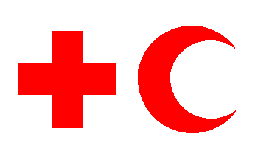 The International Federation of Red Cross and Red Crescent Societies
Placard W
Mission statement: “to inspire, encourage, facilitate and promote at all times, all forms of humanitarian activities by National Societies, with a view to preventing and alleviating human suffering, and thereby contributing to the maintenance and promotion of human dignity and peace in the world.”
There are 187 member countries in the IFRC. The red countries on the map, in the Americas, Asia, Europe, Australia, and South Africa, use the Red Cross. The green countries on the map in North Africa and the Middle East use the Red Crescent. The only blue country is Israel. They use the Red Crystal.
- The Red Cross was founded in 1919 in Paris in the aftermath of WWI
- There were five founding member societies: Britain, France, Italy, Japanese and The United States of America
- The secretariat is responsible for running everyday tasks of IFRC; however the decisions on its policies are made by the Governing body
- IFRC is the world’s largest humanitarian organization in the world
- The Red Crescent was adopted by countries that were weary of “the Cross” as the result of the Crusades and other violent acts by Christians in the Middle East.
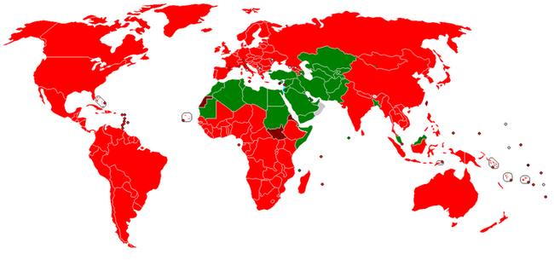
Red Cross
Red Crescent
Red Crystal

Health and Safety Services
The Red Cross is the nation’s leading provider of health and safety courses, such as CPR, First Aid and Lifeguard training. Each year, more than 9 million Americans participate in our training programs, including first responders, educators, babysitters, and people who want to be prepared to help others in an emergency.
International Services
The American Red Cross is part of the world’s largest humanitarian network with 13 million volunteers in 187 countries. Working together, we help respond to disasters, build safer communities, and educate future humanitarians. Each year, we reach an average of more than 100 million people across the globe.
Five main services the Red Cross/Red Crescent provides…
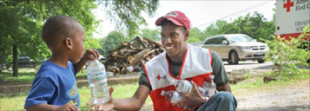Disaster Relief
Saving Lives
Supporting Military Families

