Do not understand or have never heard of this. | I remember something but not everything | I can explain this to others like the teacher | - I can …  Michigan Standards 6.1.1, 6.1.2, 6.1.3, 6.1.4, 6.2.2, 6.2.3, 6.3.1
Explain how and why the growth of industrialism was a global
phenomenon.
 |  |  | Explain when the Industrial Revolution happened. ppt
 |  |  | Explain where the Industrial Revolution happened. ppt
 |  |  | Explain why the Industrial Revolution happened in Great Britain. ppt
 |  |  | Analyze the short and long term effects of industrialization. C&Eboxes
 |  |  | Explain why the short and long term effects of industrialization were inevitable. ppt
 |  |  | Explain the term capitalism. NWT ppt
 |  |  | Explain the term communism. NWT ppt
 |  |  | Explain the term industrialization. NWT ppt
 |  |  | Explain the term labor unions. NWT ppt
 |  |  | Explain the term liberalism. NWT ppt
 |  |  | Explain the term socialism. NWT ppt
 |  |  | Explain the term urbanization. NWT ppt
 |  |  | Explain the term working class. NWT ppt
 |  |  | Analyze historical documents about the Industrial Revolution. DBQ
The Industrial Revolution
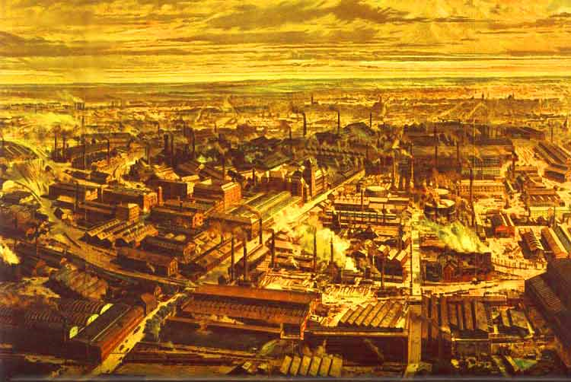
Questions I still have about the unit…

Industrial Revolution: Chapters 25 & 26

Read the chapter sections and review your class notes on a daily basis in order to complete this test review. The test is _______________________________.

For the test, be able to:
- Explain the impact of the Agricultural Revolution
- Describe the Impact of the Irish Potato Famine
- Explain Spheres of Influence
- Explain the significance of Karl Marx and outline his beliefs (Communism)
- Explain the concept of Laissez-Faire Capitalism
- Explain why transportation systems were an important part of the Industrial Revolution

HOW TO DO IDENTIFICATIONS FOR EACH UNIT

Identifications, which are worth 2 pts each, should be done in this manner:

TERM + identification phrase + interpretive commentary = 2 analytical (complex) sentences

Term + definition + why it’s important

Sample of how you will write it:
1. Nationalism: Pride in one’s country. Nationalism was responsible for the unification like countries
like Germany and Italy, and caused empires like the Ottoman Empire to break apart.

25.1 | 25.2 | Chapter 26.1
1. industrial Revolution | 16. urbanization | 28. suffrage
2. enclosures | 17. middle class | 29. Great Famine (Irish Potato)
3. crop rotation | 18. living and working condit. | 30. Mass migrations
4. industrialization
5. factors of production | 25.4
6. textiles/textile industry | 19. laissez faire
7. factory | 20. Adam Smith
8. transportation revolution | 21. capitalism
9. entrepreneur | 22. socialism
10. new agricultural rev. | 23. Karl Marx
11. James Hargreaves | 24. communism
12. Tenements | 25. unions
13. Robert Fulton | 26. strike
14. Eli Whitney | 27. women’s rights
15. James Watts

