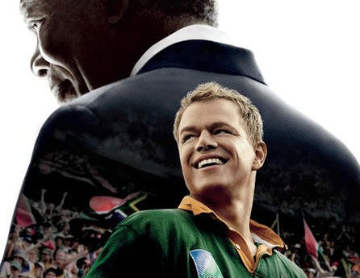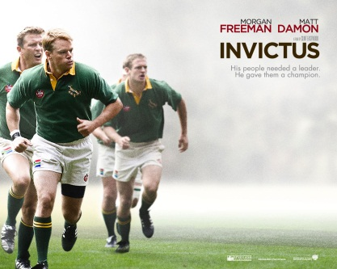
Invictus Movie Worksheet
Background Information:
- The movie “Invictus” was directed by ____________________.
- The movie is based on a book by _________________ called ____________________________: Nelson Mandela and the Game that Made a Nation.
- In the movie, actor __________________________ plays Nelson Mandela.
- ______________________ plays a character named Franciois Pienaar, the captain of the rugby team.
Comprehension Questions:
- Explain what the word apartheid means.

- What does Nelson Mandela ask the large crowd of people to do at the beginning of the movie?
  - To vote for him to become the next president of South Africa
  - To throw their weapons into the sea and to stop the violence
  - To continue their fight against the unfair practices of the apartheid.
  - To give equal rights to the black people.

- Why is it important for Nelson Mandela to have both white and black security guards?

- During the first soccer game the white people are cheering for ____________________ while the black people are cheering for _______________________.

- Why do the people in the meeting want eliminate the Springbok Rugby team?
  - The team is always losing.
  - It is the favorite rugby team of the black population.
  - It is very expensive to the country to maintain the team and pay for the games.
  - They feel the team represents the apartheid practices.

- Explain why Mandela thinks it is important to keep the Springbok Rugby team.

- Why is Robben Island important?
  - It is where Nelson Mandela spent 27 years in jail.
  - It is where the 1995 Rugby World Cup will take place.
  - It is where Nelson Mandela was born.
  - It contains many important resources like gold.

- One day Nelson Mandela decides not to go for his morning run. What happened to make him not feel like running?
  - He was very tired.
  - It was too dangerous and he was afraid someone would attack him.
  - His body asked Mandela about his family and Mandela got upset.
  - He was very worried that the Springbok Rugby team would lose the World Cup.

- Why does Mandela ask the rugby team to go play with the poor, black children?

- There is only one black player on the Springbok rugby team. His name is ____________________.
- Why does this player become so popular?

- Describe the jail where Mandela spent 27 years of his life. What does it look like? What items are in his room? What do you think it would be like to live there? (2 points)

- What work did they make Mandela and the other prisoners do while they were in jail?
  - Make license plates for cars.
  - Break rocks.
  - Peel potatoes
  - Write forgiveness letters.

- The ruby team, The All Blacks, is from the country ________________________________

