Islamic Expansion
After Muhammad
- ________________ = successor of Muhammad, or deputy
- First 4 Caliphs are known as the “rightly guided” Caliphs
  - Used _____________________ actions and the Qu’ran as _________________________________
Islam begins to spread
- Jihad = _________________________
- Armed struggle ____________________________________ (Use of term from the Qu’ran)
- This idea is used to promote the _______________________________
- Reasons for success
  - Well ____________________________________
  - Expert _____________________________________
  - Weak Empires to the north
  - Persecuted _________________to the north __________________________________ for the Muslim expansion.
Religious tolerance throughout Empire
- Qu’ran forbids forced ___________________________________
- Muslim Empire allows Jewish and Christian populations to __________________________________________________
  - Not allowed to attempt to _________________________________________ throughout the Empire
- Muslims _______________________________to convert those who came under control
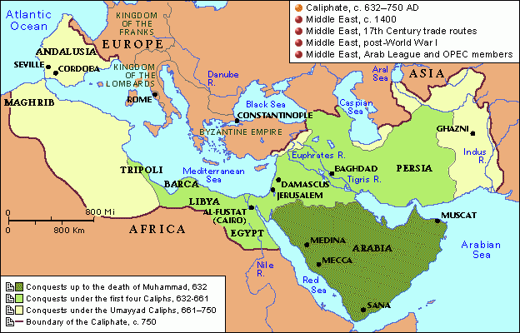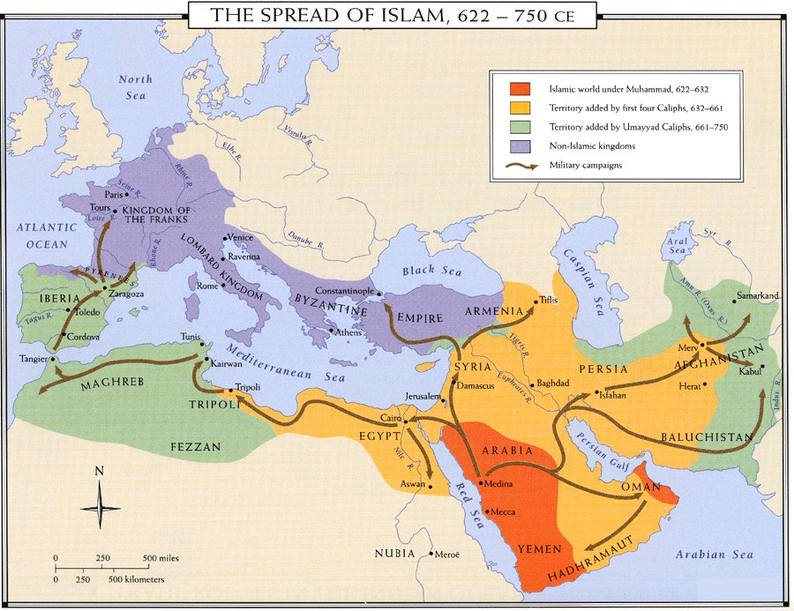

Umayyad Rule
- Moved capital to ____________________________________
  - Made controlling ______________________________areas easier
- Lived a lavish lifestyle
  - This upset a ______________________________________________________________
  - Will create a division among ____________________________________________
Division of Islamic Faith
Sunni
- ___________________________________ of Islamic people
  - ___________________________________
- Followed ___________________________________ rule
- Believe Muslim rulers should follow ___________________________________________
- Believe Shi’a have ____________________________ parts of Qu’ran
Shi’a
- Referred to as Shi’ites
- _______________________ Umayyad rule
- Believe Muslim rulers should be ____________________________________
- Believe Sunni have __________________________ parts of the Qu’ran.
Abbasid Rule
- __________________________ rule and took control of Empire in 750 A.D.
  - One Umayyad Prince survived and _____________________________ and set up a caliphate
    - Spain already held by _____________________________________
- Moved capital to ____________________________
  - Becomes a ___________________________________________
    - ___________________________, information flow through the city from different areas
- Developed __________________________ to oversee the growing Empire

