McDonaldization – Placard DD
McDonaldization is the term invented by George Ritzer to describe a sociological phenomenon where society reflects the workings of a fast food industry. It started with Ray Kroc in the 1950's when he bought his first hamburger restaurant, but its origins were actually much earlier than that. In fact, Henry Ford was the first McDonaldization pioneer when he used the assembly line for improving the production of automobiles. His revolutionary idea dramatically changed how many automobiles could be produced and was very efficient.
The process of McDonaldization takes a task and breaks it down into smaller tasks. This is repeated until all tasks have been broken down to the smallest possible level. Then the single most efficient method for completing each task is determined. All other methods are then deemed inefficient and are discarded. The result is an efficient, logical sequence of methods that can be completed the same way every time to produce the desired outcome. The outcome is predictable. All aspects of the process are easily controlled. Additionally, quantity (or calculability) becomes the measurement of good performance. This all sounds pretty good. After all, being more efficient is a good thing. Controlled, consistent and measurable outcomes also sound good. So, what's the problem?
It turns out that over-rationalizing a process in this manner has an unexpected side effect. It's called irrationality. This means that a rationalized system may result in events or outcomes that were neither anticipated nor desired, and in fact, may not be so good. Take the example of the McDonald's chain of restaurants. Where is the irrationality? The premise of fast food often turns out to be just the opposite - long waits in lines. Fast food is extremely unhealthy and the taste is bland. The system of efficiently producing and distributing their food has some other consequences, for example, millions of tons of trash each year (disposability) and a food cultivation system of questionable ethics.
According to Ritzer, the four main dimensions of McDonaldization are:
- Efficiency - The optimum method of completing a task. The best mode of production. Individuality is not allowed.
- Calculability - Assessment of outcomes can be measured. In other words, quantity over quality. They sell the Big Mac, not the Good Mac.
- Predictability - The production process is organized to guarantee uniformity of product and standardized outcomes. All shopping malls begin to look the same and all highway exits have the same assortment of businesses.
- Control - The substitution of machine labor for human labor, either through automation or the deskilling of the work force.
There are other dimensions of McDonaldization that Ritzer didn't include with the main four, but are worthy enough for prime attention. They are:
- Irrationality - A side effect of over-rationalized systems. An example of this could be workers on an assembly line that are hired and trained to perform a single highly rationalized task. Although this may be a very efficient method of operating a business, an irrationality can be worker burnout.
- Deskilling - A work force with the minimum abilities possible to complete simple focused tasks. This means that they can be quickly and cheaply trained and are easily replaceable.
- Consumer Workers - One of the sneakiest things about McDonaldization is how consumers get tricked into becoming unpaid employees. They do the work that was traditionally performed by the company. The prime example of this is diners who bus their own tables at the fast food restaurant. They dutifully carry their trash to friendly receptacles marked "thank you." (The extreme rationalization of this is the drive-thru; consumers take their trash with them!) Other examples are many and include: ATM's, salad bars, automated telephone menus, and pumping gas.
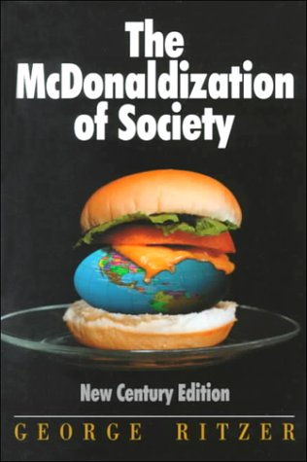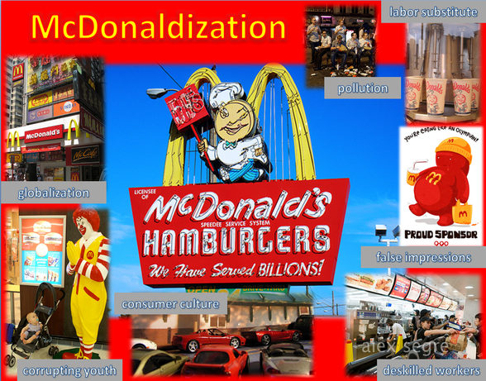
The process of Mc Donaldization takes a task and breaks it down into smaller tasks. This is repeated until all tasks have been broken down to the smallest possible level. Then the single most efficient method for completing each task is determined. All other methods are then deemed inefficient and are discarded. The result is an efficient, logical sequence of methods that can be completed the same way every time to produce the desired outcome. The outcome is predictable. All aspects of the process are easily controlled. Additionally, quantity (or calculability) becomes the measurement of good performance.

