Name: Hour: 1 2 3 4 5 6
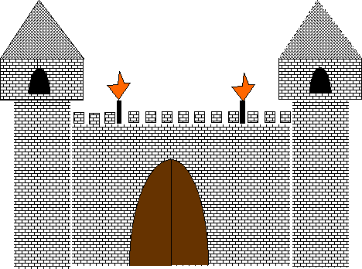
World History
Middle Ages Webquest

Directions: Locate this webquest in my teacher out box. Click on the link, and answer the questions with as much detail as possible. http://www.billtelford.net/sirgawain/Quest/medieval_webquest.htm
Knights and Fights
http://www.britainexpress.com/History/Knights_and_Fights.htm
1. How old was a boy when he was sent away to start training as a knight?

2. What was the boy called during his first stage of training?

3. How long did the first stage last?

4. What did he learn during this first stage?

5. From whom did he learn in the first stage?

6. What was the boy called during the second stage of training?

7. What did he learn during this second stage?

8. From whom did he learn in the second stage?

9. At what age did the boy become a knight?

10. To what modern day American event might the medieval tournaments be compared?

Townlife
http://www.britainexpress.com/History/Townlife.htm
1. What led to the growth of the towns?

2. Who were the most exalted members of a town?

3. Why did merchants support the king and a strong central government?

4. What did the merchant guilds regulate?

5. What three stages did a boy go through in order to become able to own a shop and be fully accepted by a
craft guild?

6. From where does the term for the second stage come, and what does it mean?

7. If a serf escaped to a town, how long did he have to stay there in order to remain free?

8. What was the penalty for a thief caught with stolen goods?

9. Why did the buildings of cooks, barbers, and brewers have to be whitewashed and plastered?

10. In addition to ringing a bell to announce news, what other job might the town crier perform?

The Lord
http://www.camelotintl.com/village/
1. What was the lord of the manor's primary duty?

2. What form of rent did the villagers (serfs) pay to the lord?

3. Most of life's necessities were produced on the fief. What are two examples of things that had to be brought
in to the fief?

4. What was the lords' and ladies' favorite past time?

5. What animals helped them in this pursuit?

6. If the lord could be compared to the U.S. president, who would be the vice-president?

7. What were the duties of the bailiff?

8. Who was the bailiff's assistant?

9. What were his duties?

10. What functions did the manor host?

Women
http://www.camelotintl.com/village/
1. What institution taught women how to behave?

2. Who were women supposed to obey?

3. Why could most women not stay at home?

4. What additional duties did they have?

5. What is an "alewife"?

6. What other jobs might urban women have?

7. How did the way single and married women dress differ?

8. What is the traditional word for a single woman? Where did this word come from?

9. What did the nunneries offer to women that life outside the convent did not?

10. Economically, how were single women landowners better off than their married counterparts?

Crime
http://www.camelotintl.com/village/
1. What was the definition of a "criminal"?

2. Who dealt with minor crimes?

3. Who dealt with major crimes?

4. What was the sheriff's job?

5. What is a "gaol"?

6. Why did the prisoners die before they came to trial?

7. How could a prisoner starve to death?

8. In order to stop highway robbers, what did a 14th century law require lords to do?

9. What were the punishments for minor crimes?

10. What were the punishments for major crimes?

Trade
http://www.camelotintl.com/village/
1. Who were the earliest medieval merchants?

2. By the beginning of the 14th century (1300), what was England importing?

3. By the beginning of the 14th century (1300), what was England exporting?

4. Where did the double-entry ledge originate?

5. Whom did merchants hire to help with paper work?

6. With what did merchants mark their papers?

7. Of what were most of the medieval coins made?

8. Where was the first gold coin since Roman times minted?

9. Where was European banking born?

10. How did banks make a profit?

The Knight
http://www.camelotintl.com/village/
1. What were the lord's words when he swore fealty to his king?

2. Why did most kings not keep standing armies?

3. Who was most likely to threaten the king's powers?

4. How did bishops become wealthy?

5. If William received the maximum number of warriors from each baron, how large would his family be?

Entertainment
http://www.camelotintl.com/village/
1. What are the five types of entertainment in which a serf could participate?

2. What did people do to celebrate Christmas, May Day, and Midsummer?

Deeper Response:
Write introduction paragraph that describes both the positives and negatives of living during the Middle Ages. Highlight or underline your thesis statement.
________________________________________________________________________________________________________________________________________________________________________________________________________________________________________________________________________________________________________________________________________________________________________________________________________________________________________________________________________________________________________________________________________________________________________________________________________________________________________________________________________________________________________________________________________________________________________________________________________________________________________________________________________________________________________________________________________________________________________________________________________________________________________________________________________________________________________________________________________________________________________________________________________________________________________________________________________________________________________________________________________________________________________________________________________________________________________________________________________________________________

