Muslim Innovations that Shaped the World Graphic Organizer
Your graphic organizer should have a title, 10 graphics with captions, and 2 sentences per caption (for a total of 20 sentences). Each set of sentences should be something like this:
Surgery
The Muslims contributed to the field of surgery. During the time of the Muslim empires, they used dissolvable cat guts for stiches and performed the first caesarian section surgery with forceps.
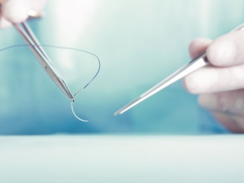 Total 20 points

Muslim Innovations that Shaped the World Graphic Organizer
Your graphic organizer should have a title, 10 graphics with captions, and 2 sentences per caption (for a total of 20 sentences). Each set of sentences should be something like this:
Surgery
The Muslims contributed to the field of surgery. During the time of the Muslim empires, they used dissolvable cat guts for stiches and performed the first caesarian section surgery with forceps.
Total 20 points.

