Name: Hour: 1 2 3 4 5 6

World History B: Unit 2
World Religions Web Quest

Directions: Answer each question with as much detail as possible. Make sure that you read the question and the article content before writing your answer.

Go to the following website. http://www.uri.org/kids/world.htm

- What mysteries of life are explained by religion?

- Go to the Buddhism tab and place your cursor over any of the pictures you see. What does Buddha’s name mean?

- Click on Celebrations. What does Wesak celebrate?

- Click on Sacred Spaces. When Buddhist’s go on pilgrimages, what are the four sacred places they visit?

- Click on Basic Beliefs. What does meditation mean?

- What are the five precepts of Buddhism?

- Click on the Christianity tab and place your cursor over any of the pictures you see. Why is the Easter Lily a sign of new birth?

- Click on Celebrations. What do Easter eggs symbolize?

- Click on sacred places. Why do most Christians worship in a church on Sunday (what is Sunday called)?

- Click on basic beliefs. What do Christians believe about Jesus?

- What are the three basic streams of Christianity?

- Click on the Hinduism tab and place your cursor over any of the pictures you see. If cows are not used for meat, what are they used for?

- Click on celebrations. What do Hindus do during the three main festivals?

- Click on Sacred Spaces. What special things do Hindus do at the Ganges River?

- Click on basic beliefs. What is found in the Vedas?

- Click on the Islam tab and place your cursor over any of the pictures you see. What is the star a sign of?

- Click on Celebrations. In Id ul-Fitr why do the people fast?

- Click on Sacred Spaces. Will you find a picture of Allah, Mohammed, or any prophet inside of a mosque.

- Click on Basic Beliefs. What does Islam mean?

- Click on the Judaism tab and place your cursor over any of the pictures you see. When men wear the skull cap, what does it symbolize?

- Click on Celebrations. On which birthday would a boy or girl have a Bar mitzvah or a Bat mitzvah?

- Click on Sacred Spaces. Why is the Western Wall called the Wailing Wall?

- Click on Basic Beliefs. What is the Torah written on?

- What is one thing that interested you about Buddhism?

- What is one thing that interested you about Hinduism?

- What is one thing that interested you about Christianity?

- What is one thing that interested you about Judaism?

- What is one thing that interested you about Islam?

Part Two: World Religions Map

Using the link, create a key and color the map according the religion practiced in the country
Go to the following website: http://www.mapsofworld.com/world-religion-map.htm
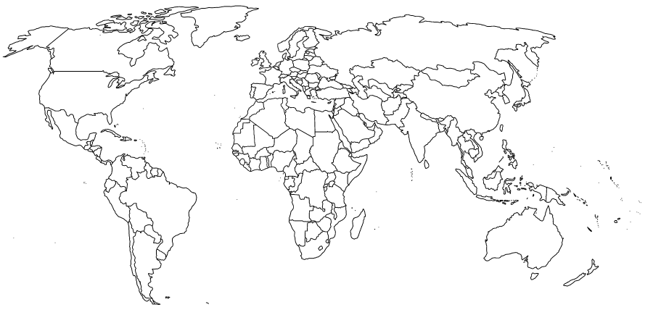
Map Key: Select colors of your choice.
Christianity
Islam
Buddhism and Taoism
Buddhism
Hinduism
Judaism

