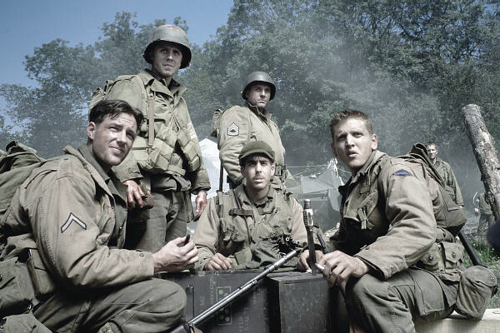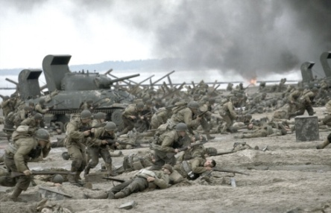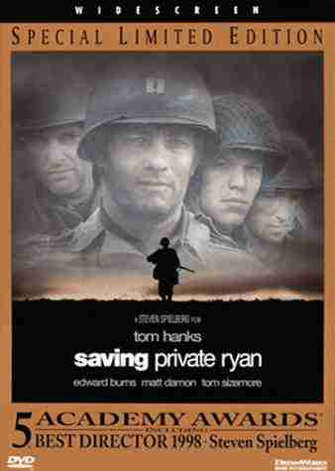

Worksheet for the Movie “Saving Private Ryan”
Presented by : Tim Stapleton Length of clip : 22 minutes

Introduction to The Movie

- The movie “Saving Private Ryan” takes place after ______ - Day – which was June 6th, ______________.
- This movie’s main character is Captain ______________ played by Tom Hanks. He leads a group of men into battle on D-Day and beyond.
- After successfully landing at Normandy, his superiors give him a special duty to find a Private ______________ whose 4 brothers have been killed in action.
- These men travel through ________________ ( country ) looking for Private Ryan and run into various German troops along the way.
- The actor who plays Private Ryan is _____________________________.

Introduction to THE Clip

- Tom Hanks’ group of soldiers are responsible for :
a) cat sector b) dog sector c) lion sector d) the left
- The Germans use a bunch of different defensive measures to defend the coast in this scene…. They are
_________________________ ____________________
- List 2 offensive weapons the Americans used in trying to defeat the Germans.

__________________________ ________________________
- In the end, the older marine leans down on the ground and scoops up some sand. He puts it in a tin with the word “France” on it. What other tins did he have in his bag? ______________ __________________

Historical Accuracy

1) There really was a mission after D-Day to save a Private Ryan. True or False
2) The Allies really did attack Normandy beach on June 6, 1944. True or False
3) The Germans held off this attack and eventually won WWII. True or False
